GPS and GSM based Vehicle Tracking and seat occupancy

This Project presents an automotive localization system using GPS and GSM-SMS services. The system permits localization of the automobile and transmitting the position to the owner on his mobile phone as a short message (SMS) at his request.

The system can be interconnected with the car alarm system and alert the owner on his mobile phone. This tracking system is composed of a GPS receiver, Microcontroller and a GSM Modem. GPS Receiver gets the location information from satellites in the form of latitude and longitude.
In this project we also included the seat occupancy sensors to monitor the seat vacancies in vehicles. And the sensors will send the data to the microcontroller ,The Microcontroller processes this information and this processed information is sent to the user/owner using GSM modem.

The presented application is a low cost solution for automobile position and status, very useful in case of car theft situations, for monitoring adolescent drivers by their parents as well as in car tracking system applications. The proposed solution can be used in other types of application, where the information needed is requested rarely and at irregular period of time (when requested).
Features:

- Remote communication using GSM modem.
- Sends location in the form of latitude and longitude.
- Reliable for remote tracking

Applications:

- VIP vehicle tracking.
- Child and animal tracking.
- Ambulance tracking.

This project provides exposure to the fallowing technologies:

- GSM modem.
- GPS receiver.
- Interfacing GSM modem and microcontroller.
- LCD display.
- Embedded C programming for microcontroller.
- Design of PCB.
- Hardware/Firmware design and development.
- Seat occupancy sensors

The Major Building blocks of this project are:

- Microcontroller based motherboard with regulated power supply.
- GPS Receiver for Location Information.
- GSM Modem/Mobile phone for remote communication.
- LED Indicators
- LCD display.

Software’s used:
  - PIC-C compiler for Embedded C programming.
  - PIC kit 2 programmer for dumping code into Microcontroller.

Regulated power supply:

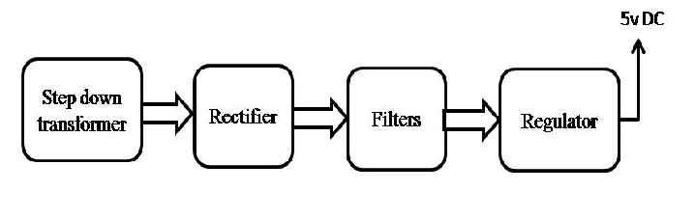

Block Diagram:

