WIRELESS CONTROL OF POWERED DEVICES WITH TONGUE MOTION

The main aim of this project is to design and construct a tongue movement controlled device switching system for physically challenged. The user can wear this device to head and with the simple tongue movement’s he can request the basic needs like water, food or medicine by using Hall-effect sensor. User can also control the electrical devices like light; fan etc with the help of tongue movements.

This hall-effect sensor finds the magnetic field and operates the electrical devices and announces the basic needs depending on input. For example if the user shows the magnet in front of sensor1 then the device will be “ON” for the first time then next time it will be “OFF”. In the same way, if the user shows the magnet in front of sensor2 then another device is going to be controlled. This device is very helpful for paralysis and physically challenged persons.

This device is portable and this system operation is entirely driven by wireless technology. User can wear it to his head like a band and can operate it by tongue movement.

This project makes use of a Relay for switching the devices and APR-9600 voice chip for audio announcements and Micro controller, which is programmed, with the help of embedded C instructions. This microcontroller is capable of communicating with transmitter and receiver modules.

The main objectives of the project are:
- Simple tongue movement based operation.
- Voice announcement of needs.
- Wireless data transmission.

This project provides us with the learning’s on the following aspects:

- Characteristics of hall-effect sensor
- Interfacing hall-effect with Microcontroller.
- Interfacing the wireless communication modules.
- Appliances interfacing with the controller.
- Embedded C programming.
- PCB Design concepts.
- APR 9600-voice circuit.

The major building blocks of this project are:
- Regulated power supply.
- Microcontrollers.
- Crystal Oscillator.
- Hall-effect sensor.
- RF transmitter and receiver modules.
- Encoder and Decoder.
- Voice circuit.
- Electromagnetic Relay.
- Reset.
- LED indicators.

Software’s used:

- PIC-C compiler for Embedded C programming.
- PIC kit 2 programmer for dumping code into Micro controller.
- Express SCH for Circuit design.
- Proteus for hardware simulation.

Regulated Power Supply:

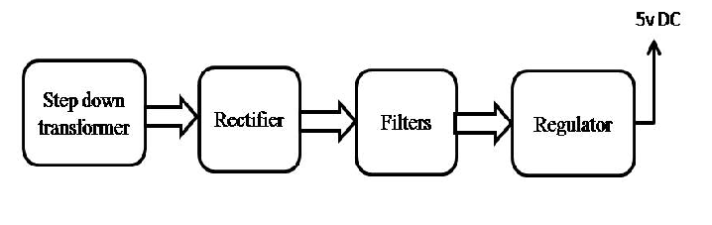
Block diagram:

