The Designing an Porting of Temperature & Humidity Sensor Node Driver Based on ARM-Linux

ABSTRACT
The places such as greenhouses, grain depot and nuclear radiation measurement require real-time monitoring of environmental temperature and humidity, so a low-cost, low-power temperature and humidity sensor network nodes based on ARM-Linux platform is designed. The project is analyzing the operating mechanism and timing sequence of DHT11 temperature and humidity sensors in detailed and studying data format and the processing method of sensor. The DHT11 temperature and humidity sensor node corresponding Linux drivers are programmed, then the temperature and humidity acquisition program porting to the ARM9-Linux2.6.18 platform. Meanwhile, the use of open-source cross-platform QT graphics library, the collected data through the graphical user interface is intuitive feedback to the user. The system has good stability and scalability, and has good application prospects in radiation measurement.

Existing Work:
The work done using a temperature and humidity sensor which exports digital signal to the controller is not sufficient in order to run a complete application in real-time scenario’s.

Proposed Work:
Proposed works include a robust self-development of kernel module for data acquisition from typical DHT11 sensor and append the values to control the devices automatically in a greenhouse environment. Based on set threshold values of temperature and humidity, the light and fan will be controlled by the ARM processor.

BLOCK DIAGRAM
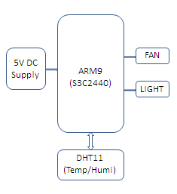

Hardware:
ARM9, DHT11 Sensor, Light, Fan.
Software:
OS: Embedded Linux, Language: C/ C++, IDE: Qt Creator.
Applications:
Atmosphere control, Industrial automation.
Advantages:
- Advantage of this project is only hardware it occupies is one GPIO Pin for data acquisition.
- It can be modified & can be applied to other working environments.

