Solar Powered Pesticide Sprayer

A Solar Operated Pesticide Sprayer is a pump running on electricity generated by photovoltaic panels or the thermal energy available from collected sunlight as opposed to grid electricity or diesel run water pumps. The operation of solar powered pumps is more economical mainly due to the lower operation and maintenance costs and has less environmental impact than pumps powered by an internal combustion engine (ICE). Solar pumps are useful where grid electricity is unavailable and alternative sources (in particular wind) do not provide sufficient energy. The solar panels make up most (up to 80%) of the systems cost. The size of the PV-system is directly dependent on the size of the pump, the amount of water that is required (m³/d) and the solar irradiance available.

The solar sprayer has many advantages. Besides reducing the cost of spraying, there is a saving on fuel/petrol. Also, the transportation cost for buying petrol is saved. The solar sprayer maintenance is simple. There is less vibration as compared to the petrol sprayer. The farmer can do the spraying operation by himself without engaging labour, thus increasing spraying efficiency.
Most of the increase in the area of irrigated land in the world has been through the increasing use of engine-driven pumps. However, the increasing price of oil-based fuel has reduced the margin to be gained by farmers from irrigation, since food prices have generally been prevented from rising in line with energy costs. Despite present short-term fluctuations in oil prices, conventional oil-based engine-driven power sources and mains electricity are expected to continue to increase in the longer term. If we are to decrease our dependence on imported oil, we have to find methods for energizing irrigation pumps that are independent of imported oil or centralized electricity. Solar radiation as a source of energy is Of course, the epitome of the clean. Sustainable energy technology except for residues possibly arising out of the manufacture of solar component (e.g. semiconductors), solar technology have very low environmental impacts. The environmental impacts of solar system in operation are very low and the source is, for us inexhaustible.
In this project We are Using Level Sensor To monitor the level of pestisied inside the tank. When the level is below then automatically an Audible alert will be given to the farmer. So that he can refill the pestisied in tank.

The major building blocks of this project are:
- Solar Panel
- Level sensor
- Battery
- DC pump
- Pestisied Tank
- Buzzer (for Low level of pestisied alert)

Objectives of the project:

- To utilize renewable energy sources for the purpose of pesticides sprayer.

- To reduce the discomfort occurs to the farmers during spraying.

- To create the awareness to the farmers about the renewable energy sources.

- To eliminate environmental pollution by using natural energy source.

- To Work efficiently under different working conditions.

- To Decrease the cost of machine

- To Decrease labour cost and maintenance cost

Advantages:

- It is multipurpose machine.

- Easy to operate and user friendly.

- Very less pollution on other models.

- It is portable

- Unit cost is very cheap one.

- Maintenances cost is low.

- Easy to assemble.

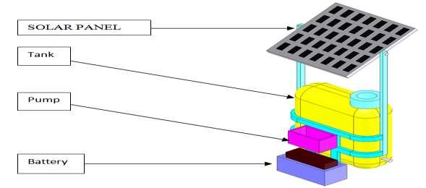
Block Diagram:

