GSM based school children security system based on RFID

The project aims in designing a system which is capable of monitoring school children and also alerting when they try to go out through SMS, buzzer alarm and display on LCD. Now a day’s technology is running with time, it completely occupied the life style of human beings. It is being used everywhere in our daily life to fulfil our requirements. We can not only increase the speed of life but also increase security with good ideas by making use of advanced technology.

The RFID tag is attached to the child before entering the school. The RFID reader is placed at the school gate monitors the child‘s enter/ exit from the school. When the child is going out of the school the RFID reader decodes that particular child’s RFID tag and alerts by sending an alerting message of the missing information to the concerned school management/teacher using GSM modem.

The task related instructions are loaded into the Microcontroller which is programmed using Embedded C language. The intelligent control software, which has been developed Embedded C programming language.

This Project consists of Microcontroller Unit, LED indicators and RFID, a buzzer alarm system and microcontroller that collect data from the RFID reader from the RFID tags which are attached to the school children. The child tracking is entirely monitored by the microcontroller.

The objectives of the project include:

- Monitoring a child using RFID technology.
- Wireless communication using GSM modem.
- A buzzer to give alerts.
- LCD to display.

The project focuses on the following advancements:

- RFID reader and Tag.
- GSM modem
- RS232 interfacing with GSM modem
- Buzzer.
- LCD.
- Embedded C programming.
- PCB designing.

The major building blocks of this project are:

- Regulated Power Supply
- RFID module.
- GSM modem.
- Crystal oscillator.
- Micro Controller
- LED indicators
- Buzzer with driver.
- LCD display with driver.

Software used:

- PIC-C compiler for Embedded C programming.
- PIC kit 2 programmer for dumping code into Micro controller.
- Express SCH for Circuit design.
- Proteus for hardware simulation.

Regulated Power Supply:

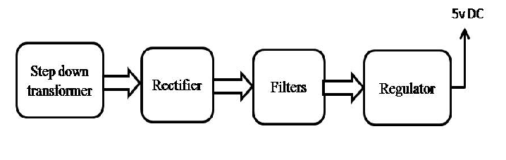
Block diagram:

