RFID BASED ADVANCED VEHICLE PARKING SLOT BOOKING SYSTEM

The project mainly aims in designing an advanced vehicle parking slot booking system for parking any vehicle in the parking area. Security is the bigger concern for an individual or a firm. Recognizing the need of security of the vehicles we developed an advanced vehicle parking slot booking system with user friendly access.

Automation is the most frequently spelled term in the field of electronics. The hunger for automation brought many revolutions in the existing technologies. One among the technologies which had greater developments is RF communications. The result of this is the RFID cards which transmit a unique identification number. This number transmitted by the RFID can be read with the help of a RF reader.

We make use of both these devices to construct an advanced slot booking system for vehicle parking system. The concerned person of the vehicle should initially book a slot using GSM mobile, when the allotted slot is confirmed then the vehicle can be allotted a particular parking area, depending on the RFID cards. The decisions like slot area is filled or vacant are taken by an onboard computer to which the RF reader is interfaced. The parking gate forms the output module and is interfaced to the same onboard computer.

This onboard computer consists of number of input and output ports. The onboard computer is commonly termed as micro controller. The input and output ports of the controller are interfaced with different input and output modules depending on the requirements. In other words micro controller acts as a communication medium for all the modules involved in the project.

The device also consists of LCD which displays the information about the status of gate open and close.

Features:

- Real time authentication system
- Low power consumption.
- Long life.
- Displaying the parking gate status (close/open)
- Highly sensitive.

This project provides exposure to the following technologies:

- RFID tags.
- RF reader.
- GSM modem.
- Interfacing GSM modem and microcontroller.
- Interfacing RFID reader and microcontroller.
- Embedded C programming for microcontroller.
- Design of PCB.
- GLCD interfacing and programming.

The major building blocks of this project are:
- Regulated power supply.
- RFID reader.
- RFID tag.
- Microcontroller.
- LCD display with driver.
- GSM modem.
- Stepper motor with driver.
- Crystal oscillator.
- LED Indicators.
- Buzzer.

Software used:

- PIC-C compiler for Embedded C programming.
- PIC kit 2 programmer for dumping code into Micro controller.
- Express SCH for Circuit design.
- Proteus for hardware simulation.

Regulated Power Supply:
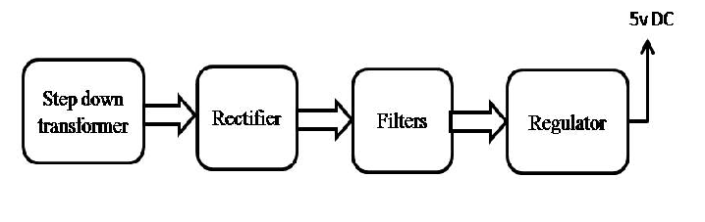
Block Diagram:

