GSM based digital notice board with display on LED scrolling Board

The project aims in designing a digital notice board with display on LED SCROLLING BOARD using a GSM modem. We can access the information directly on LED scrolling board monitor instead of getting it from the notice board. We can implement this technology in schools, colleges, banks etc… After accessing every message it automatically resets and it displays the latest message on LED scrolling board.
This project consists of an onboard computer, which consists of number of input and output ports. These onboard computers are commonly termed as micro controllers. The input and output port of the controller are interfaced with different input and output modules depending on the requirements. In other words micro controller acts as a communication medium for all the modules involved in the project.

In this project we make use of a LED scrolling board, GSM Modem, and Micro Controller. User can send the SMS messages to the modem that is connected to the Microcontroller based control system. The microcontroller automatically reads the message that is stored in SIM card and displays on LED Scrolling notice board. This process continues for every new message we send to it. The previous message will be automatically overridden by new message. A buzzer alert is given for every new message displayed on Led notice board.

Features:
- Messages can be sent from anywhere in the world.
- GSM based communication is simple to operate.
- Low power consumption.
- Buzzer alert for every new message.

Advantages:
- User-friendly interface.
- Fast data transmission and reception.
- Low power consumption.
- Can be used by anyone who knows SMS messaging operation.

The project provides learning’s on the following advancements:
- GSM modem interfacing with controller.
- Line driver MAX 232.
- RS232 cable.
- Buzzer working.
- Interfacing LED scrolling board and microcontroller.
- Conversion of AC supply to DC supply.
- Embedded C programming.
- LED Scrolling Board designing.

The major building blocks of this project are:
- Regulated power supply
- Microcontroller
- RS232 cable.
- MAX 232.
- LED indicators.
- Reset.
- Buzzer with driver.
- LCD with driver.
- Crystal oscillator.
- GSM Modem.

Software’s used:

- PIC-C compiler for Embedded C programming.
- PIC kit 2 programmer for dumping code into Micro controller.
- Express SCH for Circuit design.
- Proteus for hardware simulation.

Regulated Power Supply:
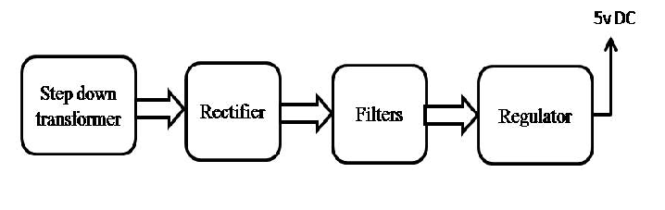

Block diagram:

