GSM based digital Notice board with display on LCD display

The project aims in designing a digital notice board with display on 16x2 LCD using a GSM modem. We can implement this technology in schools, colleges, banks etc… After accessing every message it automatically resets and it displays the latest message on LCD.
This project consists of an onboard computer, which consists of number of input and output ports. These onboard computers are commonly termed as micro controllers. The input and output port of the controller are interfaced with different input and output modules depending on the requirements. In other words micro controller acts as a communication medium for all the modules involved in the project.

In this project we make use of a GSM Modem, Micro Controller and a LCD. User can send the SMS messages to the modem that is connected to the Microcontroller based control system. The microcontroller automatically reads the message that is stored in SIM card and displays on LCD display. This process continues for every new message we send to it. The previous message will be automatically overridden by new message and buzzer alert is given for every new message.

Features:

- Messages can be sent from anywhere in the world.
- GSM based communication is simple to operate.
- Low power consumption.
- Automatic pupation of display.
- Alarm system when message is displayed.

Advantages:

- Portability.
- User-friendly interface.
- Fast data transmission and reception.
- Low power consumption.
- Can be used by anyone who knows SMS messaging operation.

The project provides learning’s on the following advancements:

- GSM modem.
- GSM modem interfacing with controller.
- Interfacing GLCD and microcontroller.
- Conversion of AC supply to DC supply.
- Embedded C programming.
- PCB designing.

The major building blocks of this project are:

- Regulated Power Supply.
- Microcontroller.
- LCD with driver.
- LED indicators.
- Reset.
- Buzzer with driver.
- GSM Modem.
- Crystal oscillator.

Software used:

- PIC-C compiler for Embedded C programming.
- PIC kit 2 programmer for dumping code into Micro controller.
- Express SCH for Circuit design.
- Proteus for hardware simulation.

Regulated Power Supply:

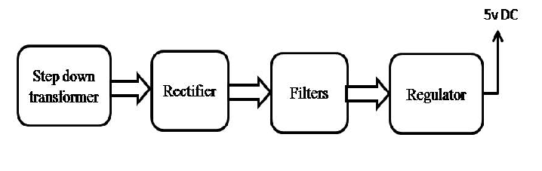
Block diagram:
