GSM based Electronic eye dial up

The purpose of this project is to provide a home security system using GSM technology. This system facilitates the house owners to monitor their home remotely from anywhere in the world through a single electronic eye. This system comprises of a Microcontroller based electronic eye monitoring system, which is a PIR sensor (Passive Infrared) that is used to detect the presence of human beings (thieves). Whenever an un-authorized entry is done, this system can dial-up or sends SMS alerts to the house owner or Police automatically using GSM modem.

This system can be mounted at any place/room that needs to be monitored. For example the house owner can mount this electronic eye or PIR sensor at one of the corners of the room so that it can cover monitoring the entire room area. Whenever a human being enters inside the room, this system senses the Passive Infrared rays emitted from the human body. This sensor output is given to the Microcontroller for further processing. Microcontroller takes necessary action like sending SMS based alarm messages, or dial to the pre-programmed phone numbers. The Microcontroller is programmed using Embedded C language. This system works well both at day and night (dark light) timing. The phone numbers to which this system should dial-up can be preprogrammed.

The features of the project are:
1. Home security system.
2. Alerts house owner if any persons presence at house.
3. Visual alerts through LCD.

The project provides the following learning’s:

- PIR sensor.
- Conversion of AC supply to DC supply.
- LCD display.
- Embedded C programming.
- GSM modem.
- PCB designing.

The Major building blocks of this project are:
- Regulated Power Supply.
- Microcontroller
- GSM Modem.
- PIR sensor.
- LCD with driver.
- Reset.
- Crystal oscillator.
- LED Indicators.

Software’s used:

- PIC-C compiler for Embedded C programming.
- PIC kit 2 programmer for dumping code into Micro controller.
- Express SCH for Circuit design.
- Proteus for hardware simulation.

Regulated Power Supply:

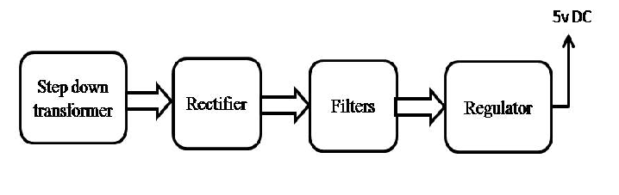
Block Diagram:

