A Remote measurement and control system for Green house based on GSM-SMS

The project aims in designing a system which provides environment for monitoring and controlling of different parameters like temperature, water level, smoke, light intensity inside green houses.

A greenhouse (also called a glasshouse) is a building where plants are grown. These structures range in size from small sheds to very large buildings. A miniature greenhouse is known as a cold frame. Greenhouses protect crops from too much heat or cold, shield plants from dust storms and blizzards, and help to keep out pests. Light, water level and temperature control allows greenhouses to turn non arable land into arable land, thereby improving food production in marginal environments.

The modules in this project are: LDR (Light Dependent Resistor) which gives information about light intensity, temperature sensor which continuously gives the green house temperature, water level sensor which helps in monitoring the water level in green house, smoke sensor which informs about smoke content in green house (usually smoke occurs in green house when fire accident takes place), LCD to display the parameters, Relay to maintain water level and GSM modem to send the parameters to remote location.

The controlling device of the project is a Microcontroller. The controller gets different parameters like light intensity, temperature, water level, smoke content as input. The Microcontroller processes this information and displays them on LCD display. Whenever water level is low, the controller switches ON the motor connected to relay. These parameters can be monitored by just sending an SMS to the number in GSM modem interfaced to Microcontroller in a predefined format. The controller validates this SMS and sends reply SMS with parameter values to the number. The microcontroller is programmed using Embedded C language.

The main objectives of this project are:

- Maintaining the conditions suitable for Green house.
- Monitoring the Green house remotely.

The project provides the following learning’s:

- Different sensors (Temperature, water level, smoke)
- LDR (Light Dependent Resistor).
- Relay.
- GSM technology.
- Interfacing GSM modem to Microcontroller.
- Interfacing sensors to Controller.
- Embedded C programming.
- Conversion of AC supply to DC supply.
- PCB designing.

The main building blocks of the project are:

- Regulated power supply.
- Temperature sensor.
- Water level sensor.
- Smoke sensor.
- Reset.
- LCD display with driver.
- LDR (Light Dependent Resistor).
- Relay with driver.
- GSM modem.
- Crystal oscillator.

Software used:

- PIC-C compiler for Embedded C programming.
- PIC kit 2 programmer for dumping code into Micro controller.
- Express SCH for Circuit design.
- Proteus for hardware simulation.

Regulated Power Supply:

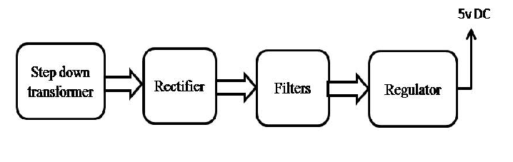
Block diagram:
