Automated bus-stop alert for passengers using GPS

The aim of the project is to design an embedded system which is capable of alerting the person through voice about the bus stop. Generally a person new to town/city finds difficulty in getting off the bus at proper station. This system alerts the person with location name whenever a station has reached.

This system consists of a GPS receiver, a voice circuit. GPS stands for Global Positioning System. GPS is a technology through which the location can be known. This system uses satellites to calculate the location on the earth. A GPS receiver is required to get the location which receives continuously the location and time information from the satellites. Voice circuit is a system which is capable of storing voices and playing back the stored voices when requested. This system eliminates the usage of old alarm systems and makes to configure the alerts through voice.

The controlling unit of the system is a Microcontroller. GPS receiver and voice circuit are interfaced to the Microcontroller. The controller is programmed in such a way that the GPS data is continuously compared with the bus stop locations and alerts through predefined voice message of that location if both matches. The Microcontroller is programmed using Embedded C language which provides a very efficient way of performing the task.

The main objectives of the project are:

- Automatic bus stop alerts through voice.
- Usage of GPS technology.

This project provides us learning’s on the following advancements:

- GPS technology.
- RS232 protocol implementation.
- Voice circuit.
- Embedded C programming.
- PCB design.

The major building blocks of this project are:

- Regulated Power Supply.
- Global Positioning System (GPS Receiver).
- Micro controller.
- Voice circuit.
- Reset.
- Crystal oscillator.
- LED indicators.

Software used:

- PIC-C compiler for Embedded C programming.
- PIC kit 2 programmer for dumping code into Micro controller.
- Express SCH for Circuit design.
- Proteus for hardware simulation.

Regulated Power Supply:

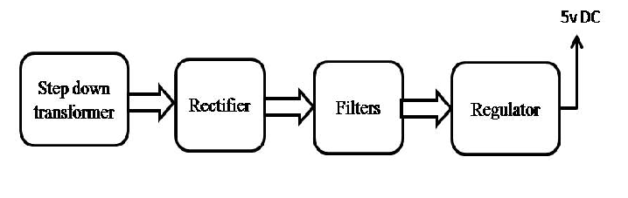
Block diagram:

