GPS BASED STATION NAME ANNOUNCEMENT AND DISPLAY FOR TRAINS/BUSES

The project aims in designing a system which is capable of announcing the station name when train enters the station which will be helpful for passengers traveling in AC coaches as well as for non local passengers who may not have idea about the local areas. Due to the presence of this device the passengers need not depend on the strangers about the arrival of their station.

The GPS is the acronym for Global positioning system. This GPS receiver is capable of identifying the location in which it was present in the form of latitude and longitudes. This information is very useful and can be processed for alerting the boat drivers. The GPS gives the data received from the satellites. For this information the GPS receiver communicates with at least three satellites in the space.

The functioning of the device is achieved by employing a microcontroller. The microcontroller forms the controlling unit of the project. The micro controller is interfaced with a GPS receiver so that it can receive the information about the location in which the train is present. When the station location is received it automatically activates the voice circuit to announce predefined station name relating to that coordinates. Also, the station name is displayed on GLCD screens. The Microcontroller is programmed using embedded C language to perform the task effectively..

Features:
- Displays station name on GLCD.
- Provides visual indication with LED indicators.
- Provides audio indication with voice based circuitry indicators

This project provides learning’s on the fallowing advancements:
- Characteristics of GPS.
- Interfacing GPS receiver to Microcontroller.
- Embedded C programming.
- GLCD interfacing to Microcontroller.
- PCB design.

The building blocks of this project are:

- Regulated Power Supply.
- GPS receiver.
- Voice circuit.
- GLCD display with driver.
- Micro Controller.
- Crystal oscillator.
- Reset.
- LED Indicators.

Software’s used:

- PIC-C compiler for Embedded C programming.
- PIC kit 2 programmer for dumping code into Micro controller.
- Express SCH for Circuit design.
- Proteus for hardware simulation.

Regulated Power Supply:

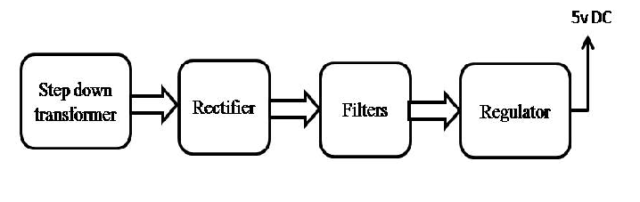
Block diagram:

