Design and Implementation of intelligent Urban Irrigation System

This project aims in providing a user friendly, reliable and automated water pumping system for illiterates. Now a day’s technology is running with time, it completely occupied the life style of human beings. Even though there is such an importance for technology in our routine life there are even people whose life styles are very far to this well known term technology. So it is our responsibility to design few reliable systems which can be even efficiently used by them. This basic idea gave birth to the project design and construction of intelligent irrigation system for illiterates and this project aims in introducing the automation technology into the lives of the illiterates.

The project aims at developing a system which helps in monitoring and alerting the geo weather parameters like temperature, humidity. The project records all these parameters temperature, humidity and fed as input to the microcontroller. This data helps meteorologists to analyze the weather conditions very easily from time to time. The microcontroller takes the responsibility to control the irrigation water pump and alert the user through SMS messages from GSM modem.

Micro controller forms the controlling module and it is the heart of the device. The controller performs the functionality of receiving data from the different sensors connected to it like temperature, humidity. The controller takes the input from the sensors and depending on that it both controls the irrigation water pump using relay and displays the status on LCD. The system also alerts the user through SMS messages about the status of the water pump. The Microcontroller is loaded with a program written in embedded ‘C’ language to perform the task.

The major features of this project are:

- User friendly interfacing.
- Controls high voltage water pumps.
- Automatic control of water pump.
- Feedback generated with the help of LED indicator.
- Automatic alerting through SMS messages.
- Highly sensitive.
Applications:

- Utilized for irrigation purpose.
- For house hold automations.

This project provides us learning’s on the following advancements:

- RS232 protocol implementation.
- GSM modem interfacing to microcontroller.
- Embedded C programming.
- PCB design.

The major building blocks of this project are:

- Regulated Power Supply.
- GSM modem.
- Temperature sensor.
- Humidity sensor.
- Micro controller.
- Crystal oscillator.
- Reset.
- LED indicators.
- LCD display.
- Relay.

Software used:

- PIC-C compiler for Embedded C programming.
- PIC kit 2 programmer for dumping code into Micro controller.
- Express SCH for Circuit design.
- Proteus for hardware simulation.

Regulated Power Supply:

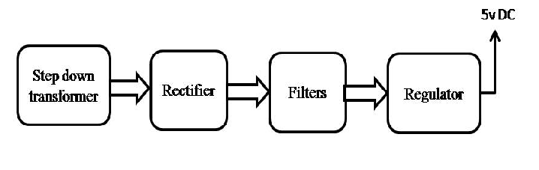
Block diagram:


