CONSTRUCTION OF TOUCH SCREEN BASED PORTABLE DIGITAL CLOCK

The project aims in designing a portable digital clock with display on GLCD by using Real Time Clock (RTC) and touch screen based inputting system.

Touch screens provide fast access to any and all types of digital media, with no text-bound interface getting in the way. Faster input can mean better service. Using a touch interface can effectively increase operator accuracy, reduce training time, and improve overall operational efficiencies, thus keeping costs down, a properly designed touch interface can improve each operator's accuracy. Touch screens are practical in automation, which has become even simpler with touch screen technology. Owners familiar with the icon system appreciate touch screens that make automation systems user friendly.

Our project touch screen based digital clock introduces us with the technology of interfacing a touch screen based Graphical LCD to a normal wall clock and operate it with help of bear hand. This project gives us the exposure about how to efficiently make use of the touch screen technology to interface with the appliances in our practical life. It can also be operated very easily with the hand so can be used even by very old people and also by the illiterates. This system also provides the options for user setting the time and also the format in which it should be displayed.

The project mainly consists of a Micro controller which acts as heart of the device. The micro controller is interfaced with a RTC module, touch screen based sensor and also to the Graphical LCD to display the output of the clock. The controlling device Microcontroller is programmed using Embedded C language.

Features:
- Touch screen based user friendly interfacing.
- Display on digital LCD.
- Dynamic selection of time format and time.
This project provides learning’s on the following advancements:

- Touch screen sensors.
- Touch screen interfacing to Microcontroller.
- GLCD displays.
- RTC module.
- Embedded C programming.
- PCB design.

The major building blocks of this project are:

- Regulated Power Supply.
- RTC module.
- GLCD with driver.
- Crystal oscillator.
- Micro Controller.
- Touch screen sensor.
- Reset.
- LED indicators.
Software used:

- PIC-C compiler for Embedded C programming.
- PIC kit 2 programmer for dumping code into Micro controller.
- Express SCH for Circuit design.
- Proteus for hardware simulation.

Regulated Power Supply:
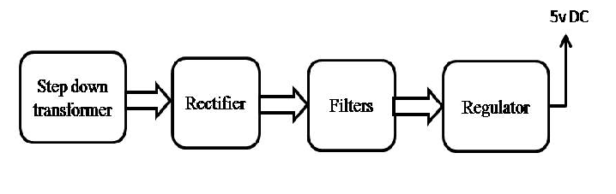
Block diagram:

