Zigbee/Bluetooth and Touch screen controlled PC

The main aim of this project is to design completely automated system to control PC using Zigbee/Bluetooth and Touch screen based technology. We can control PC by using Touch screen instead of using keyboard. There is no need of a person to sit in front of PC it can be controlled through some distance by using wireless technology called Zigbee.

Touch screens provide fast access to any and all types of digital media, with no text-bound interface getting in the way. Faster input can mean better service. Using a touch interface can effectively increase operator accuracy, reduce training time, and improve overall operational efficiencies, a properly designed touch interface can improve each operator's accuracy. Touch screens are practical in automation, which has become even simpler with touch screen technology. Owners familiar with the icon system appreciate touch screens that make automation systems user friendly.

Zigbee is a WPAN technology based on the IEEE 802.15.4 standard. Unlike Bluetooth or wireless USB devices, ZigBee devices have the ability to form a mesh network between nodes. Meshing is a type of daisy chaining from one device to another. This technique allows the short range of an individual node to be expanded and multiplied, covering much larger area.

The device consists of a microcontroller, which is interfaced with the input and output modules, the controller acts as an intermediate medium between both of them. So the controller can be termed as a control unit. The input module is nothing but a touch screen sensor, which takes the input from the user and provides the same to the microcontroller then the data is transmitted through Zigbee. At the receiving end data is decoded by the receivers Zigbee and this data is fed to the PC through serial communication port. This serial data is read using a small software application at the PC end and respective applications are handled
Features:

- Touch screen based user-friendly interfacing.
- Low power consumption.
- No need of a person to sit in front of PC
- Highly sensitive
- Implementation of REAL TIME embedded system which involves hardware and software interaction.

This project provides exposure to the following technologies:

- Touch screen sensor.
- Zigbee technology.
- Embedded C programming.
- Conversion of AC supply to DC supply.
- Design of PCB.
- Graphical LCD interfacing.
- Wireless Data Transmission over Zigbee protocol.

The major building blocks of this project are:

- Regulated power supply.
- Microcontroller.
- Touch screen sensor.
- Zigbee/Bluetooth module.
- Graphical LCD.
- Microcontroller.
- MAX232 based serial interfacing.
- Crystal oscillator.
- LED indicators.
Software used:

- PIC-C compiler for Embedded C programming.
- PIC kit 2 programmer for dumping code into Micro controller.
- Express SCH for Circuit design.
- Proteus for hardware simulation.

Regulated Power Supply:

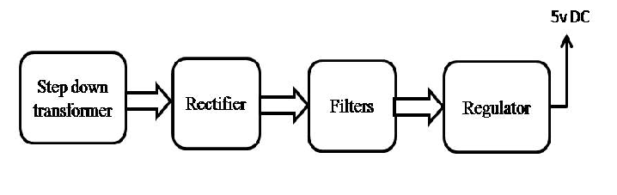

Block Diagram:
