GSM based wireless Substation Fuse blown Indicator
The project aims at building an automated wireless monitoring and alerting system for a fuse in a substation. The substation consists of very high voltage devices, which require continuous and uninterrupted power supply. To provide an uninterrupted power to the substation there is a necessity of a device, which is capable of monitoring the fuse status. Our device not only monitors the fuse but also provides a wireless feed back to the remotely present authority automatically and the feedback can also received on request basis. The alert is also given at substation through buzzer.

This project consists of two electrically isolated power sensors for sensing the presence of electrical power. One of the power sensors is connected before the fuse to be monitored and the other after the fuse. The power status from these sensors is fed to a microcontroller. Microcontroller continuously monitors the status of these two sensors.

If the power status of second sensor is low and the first sensor is high, then the microcontroller identifies this as a break in fuse circuit and sends an appropriate message to the remote user. For alerting the remote user the system makes use of the GSM modem, which was interfaced to it. The end user receives the alert messages in the form of SMS, which describes the fuse status. The end user can also know the fuse status by sending an SMS to this device. To, perform this intelligent task; Microcontroller is loaded with an intelligent program written using embedded ‘C’ language.

The objectives of the project include:

- Real-time fuse monitoring.
- Generation of wireless alerts to the remote user using GSM technology.
- Alerting the substation in charge regarding fuse blown out through buzzer.

The project provides exposure on the following technologies:

- Electrical isolation between two devices.
- Embedded C programming.
- PCB designing.
- Serial communication between the micro controller and GSM modem.
- Implementation of RS232 protocol.

The major building blocks of this project are:

- Regulated power supply.
- Microcontroller.
- Two electrically isolated power status sensors.
- GSM modem.
- LED indicator.
- Buzzer with driver.
- LCD with driver.
- Crystal oscillator.
- Reset button.

Software used:

- PIC-C compiler for Embedded C programming.
- PIC kit 2 programmer for dumping code into Micro controller.
- Express SCH for Circuit design.
- Proteus for hardware simulation.

Regulated Power Supply:

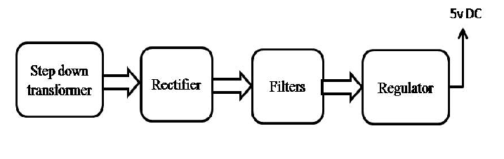

Block Diagram:

