ENERGY CONSERVATION SYSTEM FOR CORPORATE COMPUTERS AND LIGHTINING SYSTEMS USING PIR

The project aims in designing a system which is capable of detecting human presence and automatically adjusts the light intensity and also switches ON/OFF the computer.

Power conservation, which has become a major challenge for the users and that, is the driving idea behind our project. Power conservation system can be successfully designed only when it is interfaced with automation system. This kind of power conservation systems finds their vast application in the IT companies, banking sectors, Public organizations, and large-scale industrial sectors. Here large number of High voltage as well as low voltage devices is employed to fulfill different consumer as well as the employ needs. In this kind of scenario there is a need to replace the switches and other fuses with relays and circuit breakers to design systems, which are capable of switching very high voltage devices and also low voltage devices.

The controlling device of the whole system is a Microcontroller. PIR sensor and Relay are interfaced to Microcontroller. PIR sensor continuously checks the human presence and feds as input to the Microcontroller. Each cabin is equipped with a PIR sensor. Whenever any human presence is detected in the cabin the intensity of the lights will be increased and also the computer is switched ON. Whenever human is not present, automatically light intensity is decreased and switches OFF the computer which results in energy conservation.

The main objectives of the project are:

- Energy conservation.
- Human presence detection.
- Low power consumption.
The project focuses on the following areas:

- Characteristics of PIR sensor.
- Interfacing PIR sensor to Microcontroller.
- High voltage device controlling.
- Intensity controlling technique.
- Embedded C programming.
- PCB designing.

The major building blocks of this project are:

- Regulated power supply.
- Microcontroller.
- Passive Infra Red Sensor (PIR).
- Interfacing Circuit (Relay with driver).
- Reset.
- Crystal oscillator.
- LED indicators.

Software used:

- PIC-C compiler for Embedded C programming.
- PIC kit 2 programmer for dumping code into Micro controller.
- Express SCH for Circuit design.
- Proteus for hardware simulation.

Regulated Power Supply:

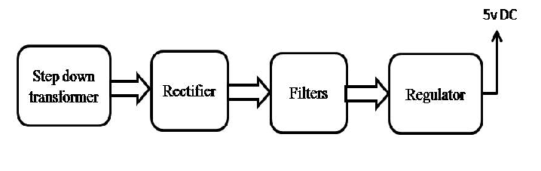

Block diagram:

