TOUCH SCREEN OPERATED PASSWORD PROTECTED LIQUID DISPENSING SYSTEM

The project aims in designing a system which is capable of dispensing required amount of liquid given by the user. This system also provides the security of accessing through password enabled feature. Liquid dispensing systems are quite commonly found in our daily life in different places like offices, Bus stands, Railway stations, Petrol pumps. Here we are going to present modern era liquid dispensing system which is meant to be operated with touch screen interfacing. Operators of the dispensing systems should be trained perfectly so that they hold the controls until the required amount of liquid is dispensed instead of this hard core mechanism we are designing with a touch screen based dispensing system which is going to dispense the particular to the required amount and is turned off immediately, the major advantage here is there is no need for any mandatory person to take care about the system. This system needs a password for activation and activates only when password entered is correct.

Touch screens provide fast access to any and all types of digital media, with no text-bound interface getting in the way. Faster input can mean better service. Using a touch interface can effectively increase operator accuracy, reduce training time, and improve overall operational efficiencies, thus keeping costs down, a properly designed touch interface can improve each operator's accuracy. Touch screens are practical in automation, which has become even simpler with touch screen technology. Owners familiar with the icon system appreciate touch screens that make automation systems user friendly.

The system is designed with a Micro Controller which is the heart of the device. It is interfaced with a touch screen based LCD and a dispensing motor. The user provides input to the device from the touch screen sensor. This input is read by the controller and control starts operating the dispensing motors until the required amount of liquid is dispensed. The input from sensor is also displayed on the LCD for the acknowledgement of the user.

The major features of this project are:

- Touch screen based user interface.
- Graphical LCD based display system for liquid dispensed.
- Accuracy in the amount of liquid dispensed.
- Password protected.

The project provides learning’s on the following advancements:

- Characteristics of the Touch screen.
- Touch Screen interfacing with Microcontroller.
- DC motor working.
- Embedded C programming.
- PCB design.

The major building blocks of this project are:

- Regulated Power Supply.
- Microcontroller.
- Touch screen with driver.
- LCD with driver.
- Liquid dispensing system.
- Reset.
- Crystal oscillator.
- LED indicators.

Software used:

- PIC-C compiler for Embedded C programming.
- PIC kit 2 programmer for dumping code into Micro controller.
- Express SCH for Circuit design.
- Proteus for hardware simulation.

Regulated Power Supply:

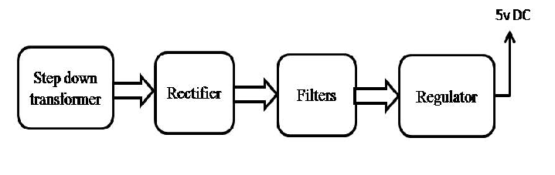
Block diagram:
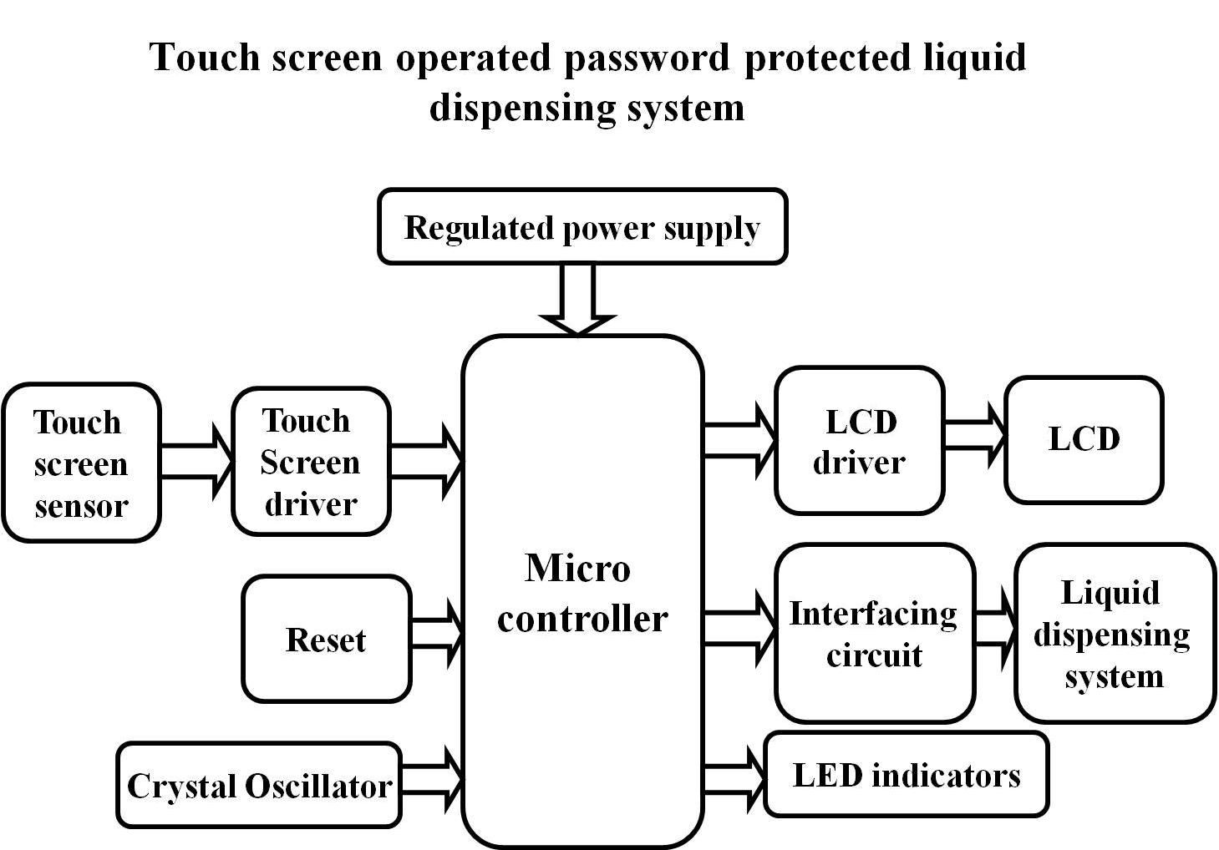
s

