DUAL GSM MODEMS BASED IRRIGATION WATER PUMP CONTROLLER FOR ILLITERATES

This project aims in providing a user friendly, reliable and automated water pumping system for illiterates. Now a day’s technology is running with time, it completely occupied the life style of human beings. Even though there is such an importance for technology in our routine life there are even people whose life styles are very far to this well known term technology. So it is our responsibility to design few reliable systems which can be even efficiently used by them. This basic idea gave birth to this project and this project aims in introducing the automation technology into the lives of the illiterates.

Here the automation process is done through the wireless GSM technology and the end user need not require any knowledge about the operation of the GSM mobile. For the efficient usage of the device the end user should know the basic switch operation which is more than sufficient to use this device efficiently.

In our project we make use of two microcontrollers one is dedicated at the water pump and the other with the user. Both the microcontrollers form the heart of the device and there are also two GSM modems which are meant for exchanging the commands from one end to the other end. The GSM modem present at the user end is interfaced with few control buttons via micro controller. The each control button has a dedicated functionality such as getting the power status at the motor, turn ON the motor etc. Whenever a control button is pressed it is identified by the microcontroller and generates an equivalent command with respect to the button pressed and forwards the same to the water pump with the help of modem. The modem at the motor receives the commands from the user and feeds the same to the microcontroller and the controller performs the equivalent action with respect to the commands received. Here commands are shared between the modems by using the SMS service.

The design of this system is very much sensitive and should be handled with utmost care because the microcontroller is a 5 volts device and it is employed to control 230V irrigation water pump. So every small parameter should be given high importance while designing the interfacing circuit between the controller and the water pump. The major advantage of this device is, it can be operated by the illiterates and the status of the motor can also be known by a simple LED indication and more over the device is very economical and can be brought available to the common man.

Features:

- User friendly interfacing.
- Controls high voltage water pumps.
- Wireless control of remote water pump.
- Feedback generated with the help of LED indicators.
- Highly sensitive.

This project provides exposure to the following technologies:

- GSM modem.
- Interfacing GSM modem and microcontroller.
- Serial communication protocols.
- Embedded C programming.
- Design of PCB.

The major building blocks of the project are:

- Regulated power supply.
- GSM modems.
- Microcontrollers.
- Control buttons.
- Crystal oscillator.
- Interfacing circuit (Relay with driver).
- Reset.
- LED indicators.

Software used:

- PIC-C compiler for Embedded C programming.
- PIC kit 2 programmer for dumping code into Micro controller.
- Express SCH for Circuit design.
- Proteus for hardware simulation.

Regulated Power Supply:

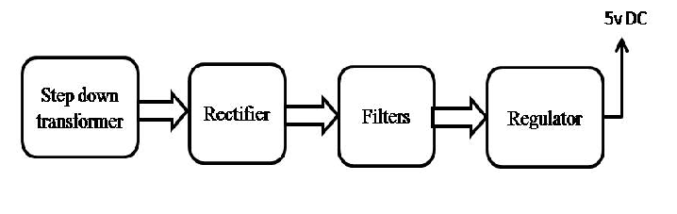

Block diagram:

