Talking Touch Home (TTH)

The project mainly aims in designing completely automated switch board with the help of touch screen sensor and a graphical LCD to control the house hold appliances and also provide a user friendly environment to operate the devices effectively. This system also provides voice based announcement system for touch operated devices. It majorly aims in providing a reliable system for illiterates and old people who finds difficulty in operating few high end devices like AC, water heaters etc.

Automation is the most frequently spelled term in the field of electronics. The hunger for automation brought many revolutions in the existing technologies. One among the technologies, which had greater developments, is the touch screen sensor. These had greater importance than any other technologies due to its user-friendly nature. Touch screen based devices can be easily reachable to the common man due to its simpler operation, and at the same time it challenges the designers of the device. These touch screen sensors can be used as a replacement of the existing switches in home which produces sparks and also results in fire accidents in few situations. Considering the advantages of touch screen sensors an advanced automation system was developed to control the appliances in the house.

The device consists of a microcontroller, which is interfaced with the input and output modules, the controller acts as an intermediate medium between both of them. So the controller can be termed as a control unit. The input module is a touch screen sensor, which takes the input from the user and fed it to the microcontroller. The output module is graphical LCD and the appliances to be controlled. Here the microcontroller receives the input from the touch sensor and switches the device with respect to the input. The controller also takes the responsibility to display the status of the individual devices on the graphical LCD.

Features:

- Touch screen based user-friendly interfacing.
- Voice based acknowledgement.
- Low power consumption.
- Controls high and low voltage devices.
- Long life.
- Highly sensitive.

Applications:

- In industrial environment where combustibles are used.
- For house hold automations.

This project provides exposure to the following technologies:

- Touch screen sensor.
- Voice circuit.
- Interfacing sensor and microcontroller.
- Embedded C programming.
- Design of PCB.
- Conversion of AC supply to DC supply.
- Graphical LCD interfacing.

The major building blocks of this project are:

- Regulated power supply.
- Voice circuit.
- Touch screen sensor.
- Graphical LCD.
- Microcontroller
- Relay with driver.
- Triac with driver.
- Crystal oscillator.
- LED indicators.

Software used:

- PIC-C compiler for Embedded C programming.
- PIC kit 2 programmer for dumping code into Micro controller.
- Express SCH for Circuit design.
- Proteus for hardware simulation.

Regulated Power Supply:

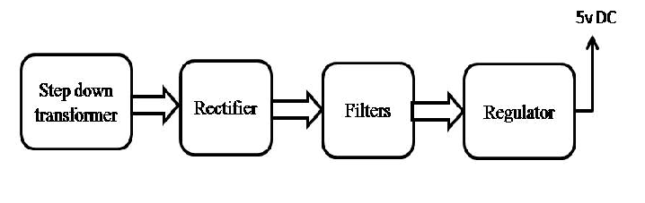

Block diagram:
