GPS based vehicle travel location data logger with 2GB MMC/SD memory card

The project aims in designing a system which is capable of logging the vehicle travelled path into a MMC/SD card and later plots this in Google Earth application on PC. Global Positioning System (GPS) has been used in various commercial applications including transportation, navigation and vehicle position tracking, which when coupled with external memory stick the technology can help track the complete journey of any vehicle or moving objects like human or animals.

This project aims to construct a vehicle position logging system using GPS and SD/MMC (Secure Digital/Multi Media Card). The system comprises of following four modules.

- GPS Data Receiver.
- SD/MMC memory card interfacing.
- RS232 Interfacing.
- Data Processing (Microcontroller).

The GPS data receiver module gets the data from GPS receiver and extracts the required data. The data storage module consists of an interface circuit between the Microcontroller and the SD/MMC card. This module transmits the data on to the SD/MMC card at the interval of two seconds. This data (At the end of the journey) is transferred to PC using RS232 communication. Data capturing is done by the HyperTerminal application on PC.

This data is utilized by PC based application for displaying on a computerized map. This captured data is superimposed on the Google Earth map, which covers major cities and towns within India and abroad.

The project works satisfactorily in real time, can locate the vehicle travel locations in the form of longitude, latitude with the margin of error not more than 6 meters from the actual location. This system also logs the information like date, time and speed information of the vehicle.

The major features of this project are:

- 2GB Memory available for storing the data.
- RS232 based data transmission.
- Mapping the route on the Google map.
- Store data of one year travel time.
- Microcontroller can format memory Card.

This project provides us learning’s on the following advancements:

- SPI protocol implementation.
- GPS Receiver Interfacing.
- Interfacing the MMC/SD card.
- Serial communication with PC.
- RS232 data transmission.
- Conversion of AC supply to DC supply.
- Embedded C programming.
- PCB design.

The major building blocks of this project are:

- Regulated Power Supply
- Microcontroller.
- GPS receiver.
- Memory Stick (MMC) with driver.
- MAX 232.
- Reset.
- Crystal oscillator.
- LED Indicators.
- Control buttons.

Software’s used:

- PIC-C compiler for Embedded C programming.
- PIC kit 2 programmer for dumping code into Micro controller.
- Express SCH for Circuit design.
- Proteus for hardware simulation.

Regulated Power Supply:

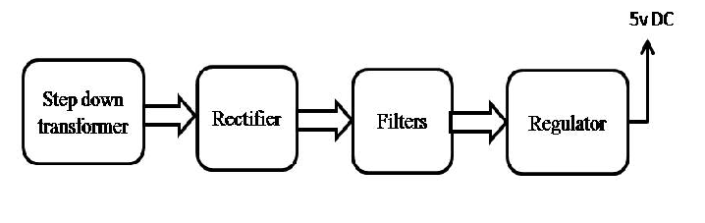

Block Diagram:

