Radio Frequency wireless remote controlled digital camera with high power LED based focusing light. The camera direction can be controlled remotely and the video images can be seen live on TV

The project aims in designing a system which provides a system for controlling the camera direction intellectual using a wireless RF remote. The video images thus recorded can be seen live on TV. It is a very low cost survey line system used to monitor a larger area using number of cameras. The entire area can be completely automated such the direction of the cameras can be controlled by a unique wireless remote. Since the frequency we are using is of radio band so that it can be also controlled from a very larger distances.

RF Communication ranges in between 30 KHz to 300 GHz. RF communication works by creating electromagnetic waves at a source and being able to pick up those electromagnetic waves at a particular destination. These electromagnetic waves travel through the air at near the speed of light. The wavelength of an electromagnetic signal is inversely proportional to the frequency; the higher the frequency, the shorter the wavelength.

The most innovative thing in the project is the usage of a high power LED that is again automated. Here the purpose of LED is to serve as a light source for the camera whenever it is operated in low intensity, the wording here means that the LED should again be controlled by controller such that it takes an input from a light sensor and glows the LED intellectually if it feels the light available in the surroundings is not sufficient enough to catch the images. By we can make sure that we also save power to some extent.

The controlling device of the whole system is a Microcontroller. The Microcontroller gets the input from RF receiver which receives the data transmitted by pressing control buttons in RF remote. This data is processed and acts accordingly on Robot and also controls the direction of Camera. The controller always checks input from LDR and switches ON High power LED, if light intensity is low. The captured video images are transmitted through AV transmitter and are received by AV receiver and displayed on TV interfaced to it.

This project finds its major applications while we are monitoring larger areas like political canvassing, cricket stadiums, international conferences, worship places, banking etc. This project assures us with more reliable and confident security system

The objectives of the project include:

- Forms the surveillance system for combing areas.
- Monitors large spaces in industrial environment.
- Wireless controlling of robot.

The project focuses on the following advancements:

- RF technology.
- Interfacing RF modules to Microcontroller
- DC motor working and need for motor driver..
- Embedded C programming.
- PCB designing.

The major building blocks of this project are:

- Regulated Power Supply
- RF Transmitter
- RF Receiver.
- Micro Controller
- DC Motor with driver.
- Crystal oscillator.
- LDR.
- LED indicators.
- High Power LED with driver.

Software used:

- PIC-C compiler for Embedded C programming.
- PIC kit 2 programmer for dumping code into Micro controller.
- Express SCH for Circuit design.
- Proteus for hardware simulation.

Regulated Power Supply:

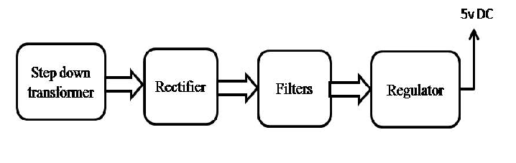

Block diagram:

