GPS based navigator with location display on Graphical LCD

The project aims in designing a GPS based navigator which displays the location on Graphical LCD in any language. This system is a micro controller based device which intellectually finds the location in which it was currently located.
GPS is the acronym for Global Positioning System. It is employed to find the position where the user is located on the earth. This information is provided by the GPS with the help of the data it receives from the satellites.
Micro controller is the heart of the device. It stores the data of the current location which it receives from the GPS system. So that it can make use of the data stored to compare with the destination location of the user. By this it can trace out the distance from the destination and produce an alert to the user in advance using GLCD by displaying the location. This device helps the people in their journeys. It helps him to get the visual alerts regarding the arrival of his destination before few minutes on GLCD display.
This device is designed to provide with a greater advantage producing visual based alerts for the user i.e. the user gets the display on GLCD in any language which initiates his destination location as and when it is about to reach the destination. This project is very much helpful for the deaf and dumb people to travel in their journeys.

The main features of this project are:
- User-friendly interaction with the user.
- Highly sensitive.
- Reliable for deaf and dumb people.
- Easy to operate.

This project provides learning’s on the following advancements:
- Characteristics of GPS.
- Display on GLCD.
- Embedded C programming.
- PCB design.

The major building blocks of this project are:
- Regulated Power Supply.
- Global Positioning System.
- GLCD Interfacing.
- Micro controller.
- LED indicators.

Software used:

1. PIC-C compiler for Embedded C programming.
2. PIC kit 2 programmer for dumping code into Micro controller.
3. Express SCH for Circuit design.
4. Proteus for hardware simulation.

Regulated power supply:

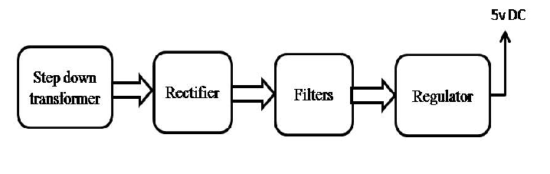

Block diagram:

