Voice enabled wireless devices switching for visually impaired

The main aim of this project is to design and construct a head movement controlled device switching system for physically challenged which also gives audio announcement related to his requirement. The user can wear this device to head and with the simple head movement’s he can control the electrical devices like light; fan etc and also the device on which operation has taken place is announced through voice.

MEMS Accelerometer is a Micro Electro Mechanical Sensor which is a highly sensitive sensor and capable of detecting the tilt. This sensor finds the tilt and operates the electrical devices and announces the basic needs depending on tilt. For example if the tilt is to the forward then the device will be “ON” for the first time then next time it will be “OFF”. In the same way, if the tilt is to the left side then another device is going to be controlled. The tilt is in left side or right side direction the related need will be announced. This device is very helpful for paralysis and physically challenged persons.

This device is portable and this system operation is entirely driven by wireless technology. User can wear it to his head like a band and can operate it by tilting the MEMS Accelerometer sensor.

This project makes use of a Relay and Triac for switching the devices and APR-9600 voice chip for audio announcements and Micro controller, which is programmed, with the help of embedded C instructions. This microcontroller is capable of communicating with transmitter and receiver modules. The MEMS Accelerometer based sensor detects the tilt and provides the information to the microcontroller (on board computer) and the controller judges whether the instruction is right movement or left movement instruction and controls the operation respectively.

The main objectives of the project are:

- Tilt based device switching.
- Voice based information on tilt related operation.
- Wireless data transmission.

This project provides us with the learning’s on the following aspects:

- Characteristics of MEMS Accelerometer.
- Interfacing MEMS with Microcontroller.
- RF technology.
- Appliances interfacing with the controller.
- Embedded C programming.
- PCB Design concepts.
- APR 9600-voice circuit.

The major building blocks of this project are:
- Regulated Power Supply.
- Microcontroller.
- MEMS Accelerometer sensor.
- RF transmitter and receiver modules.
- Crystal oscillator.
- Reset.
- Voice circuit.
- Electromagnetic Relay with driver.
- Triac with driver
- LED indicators.

Software’s used:

- PIC-C compiler for Embedded C programming.
- PIC kit 2 programmer for dumping code into Micro controller.
- Express SCH for Circuit design.
- Proteus for hardware simulation.

Regulated Power Supply:
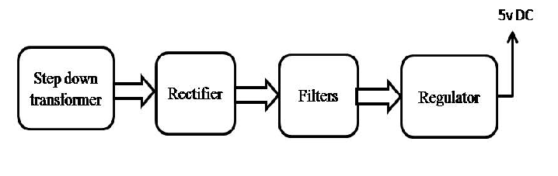
Block diagram: 