Mobile Phone controlled PC with Devices Control

The main aim of this project is to control the computer system and electrical devices using a mobile phone with DTMF technology. Instead of using mouse, one can use this device from certain distance. This device can perform all the functions that mouse carries like, Left-click, Right-click and movement of the curser.

This project consists of a mobile phone (or land phone) for controlling the PC and electrical devices from a remote location. User has to operate the PC within the visible distance. For example user can operate the PC kept at railway stations or waiting halls with his mobile phone. This project consists of Microcontroller based control system attached to the PC. A DTMF decoder is connected to the microcontroller as input device. This device is connected to a mobile phone and also with the microcontroller. DTMF decoder decodes the signals from the mobile phone and converts them into a four-bit signal. This four bit data is then fed to the microcontroller for further processing. Based on this the microcontroller sends information to the application running on PC through a RS232 serial cable interface. The software running inside the pc takes the responsibility of controlling the mouse pointer and other application in PC.

Here the receiver at the computer end is capable of receiving a set of command instructions in the form of DTMF tones and performs the necessary actions. Here DTMF stands for “Dual tone multiple frequency”. Automated sensors and remote communication aims at building a highly automated wireless system, which can be monitored with the help of a remote mobile. The employment of the mobile into the project makes the device to overcome distance limitation.

Features:

- Controlling of PC through Mobile phone.
- Controlling of electrical appliances using mobile phone.
- Wireless communication.
- Eliminates distance limitation.

This project provides us with the learning’s on the following aspects:

- Interfacing serial port with Microcontroller.
- DTMF technology.
- Embedded C programming for microcontroller.
- PCB layout design.
- Understanding Diac and Triac switching.
- Electromagnetic Relay interfacing.

The major building blocks of this project are:

- Regulated power supply.
- Microcontroller.
- Electromagnetic Relay with driver.
- Triac with driver.
- DTMF decoder.
- LED Indicators.
- MAX232.
- Crystal oscillator.
- Reset.

Software used:

- PIC-C compiler for Embedded C programming.
- PIC kit 2 programmer for dumping code into Micro controller.
- Express SCH for Circuit design.
- Proteus for hardware simulation.

Regulated Power Supply:

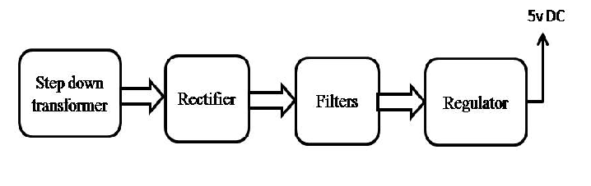Block diagram:
