DTMF controlled Live Human Being Detection Robot with video camera mounted on it

The project aims in designing a automatic monitoring system for controlling the camera direction intellectual using a wireless remote placed on a Robot. The video images thus recorded can be seen live on TV. It is a very low cost survey line system used to monitor a larger area using number of cameras. The entire area can be completely automated such the direction of the cameras can be controlled by a unique mobile. Also, this robot detects person’s presence and horns an alarm is present.

The most innovative thing in the project is the usage of a high power LED that is again automated. Here the purpose of LED is to serve as a light source for the camera whenever it is operated in low intensity, the wording here means that the LED should again be controlled by controller such that it takes an input from a light sensor and glows the LED intellectually if it feels the light available in the surroundings is not sufficient enough to catch the images. By we can make sure that we also save power to some extent.

In this project we use micro controller, which is programmed to control the input and output modules interfaced to it. The controller gets input from DTMF decoder depending upon which, the DC motors can be rotated. The Microcontroller is programmed using Embedded C language.

Also a mobile phone which will operates the robot directions and speed based on the DTMF technology. DTMF (Dual Tone Multiple Frequency) depends upon the keypad tones where as each tone can generate certain frequency depending on that, the robot will operated. The micro controller interfaced with DTMF decoder to control the direction of the robot. LED indicators indicate the motor ON/OFF status. The mobile phone acts as a remote control of the Robot.

The main objectives of this project are:
- Design of real time robot.
- Wireless control of robot directions and movement.
- Forms the surveillance system for combing areas.
- Monitors large spaces in industrial environment.
- Wireless video transmission over RF.
- A buzzer to give alerts.
The learning’s provided by the project are:
- DTMF technology.
- Interfacing DTMF decoder with controller.
- DC motor working and need for motor driver.
- PIR sensor.
- Embedded C programming.
- PCB design concepts.
The major building blocks of this project are:
- Regulated Power Supply.
- Microcontroller.
- DTMF decoder.
- DC Motors with driver.
- Crystal oscillator.
- Buzzer with driver.
- LDR.
- PIR sensor.
- High power LED with driver.
- LED Indicators.

Software used:

- PIC-C compiler for Embedded C programming.
- PIC kit 2 programmer for dumping code into Micro controller.
- Express SCH for Circuit design.
- Proteus for hardware simulation.

Regulated Power Supply:

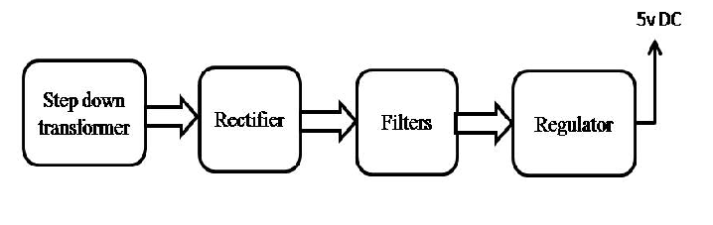Block diagram
