Smart card and GPS based automatic bus ticketing system for travelled distance

The project aims in designing a system which automatically measures the travelled distance by a passenger in bus and debits the fare for travelled distance from the passenger account. This feature helps in avoiding direct cash method used presently for ticketing.

The modules in the project are: GPS receiver which keeps track of the distance travelled by the passenger, smart card reader which is capable of reading the information of bank account details of passenger when swiped, keypad to enter the password of the smart card, LCD to display the travelled distance and fare.

The controlling device of the whole system is a Microcontroller. GPS receiver, keypad, smart card reader, LCD display are interfaced to the controller. When a person boards a bus, he needs to swipe the smart card to the smart card reader present at the entrance and password should be entered by keypad. The location coordinates at that instant given by GPS receiver will be stored against his smart card number in the Microcontroller and when he exits the bus, he need one more swipe of smartcard which gets the location coordinates of exit point and the Microcontroller calculates the distance travelled and fare and displays them on the LCD screen. Also, the amount will be deducted from the passenger account. The Microcontroller is programmed using Embedded C language which provides effective environment for performing the task.

The main objectives of this project are:
- Automatic ticketing.
- Direct cash fare collection is avoided.
- Usage of smart card technology.
- Providing security through password.
The project provides the following learning’s:

- GPS technology.
- Smart card technology.
- Embedded C programming.
- PCB designing.
- Conversion of AC supply to DC supply.
- Serial communication protocols.
- Interfacing smartcard reader to Microcontroller.
- Interfacing GPS receiver to Microcontroller.

The main building blocks of the project are:

- Regulated Power Supply.
- Microcontroller.
- GPS receiver.
- Smartcard reader.
- LCD display with driver.
- Crystal oscillator.
- LED indicators.
- Keypad.
- Reset.

Software’s used:

- PIC-C compiler for Embedded C programming.
- PIC kit 2 programmer for dumping code into Micro controller.
- Express SCH for Circuit design.
- Proteus for hardware simulation.

Regulated Power Supply:

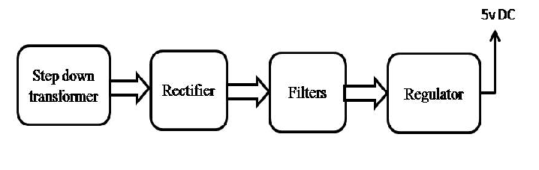

Block Diagram:

