Wireless 3-phase motor starter using RF technology with
Feedback indicators

The main aim of this project is controlling of 3-phase motor using wireless technology based on RF. The project was designed in such a way that user can easily switch ON/OFF the 3-phase motor at distance of RF module range.

RF Communication ranges in between 30 KHz to 300 GHz. RF communication works by creating electromagnetic waves at a source and being able to pick up those electromagnetic waves at a particular destination. These electromagnetic waves travel through the air at near the speed of light. The wavelength of an electromagnetic signal is inversely proportional to the frequency; the higher the frequency, the shorter the wavelength.

In this project control buttons are used to send the data through the RF transmitter to the receiver which is at the motor end. We use micro controller at the receiver end, which is programmed to control the output modules depends on the input. The controller takes input from the RF receiver to control the 3-phase motor using relays through the starter and it is indicated through LED’s.

The project consists of micro controller based motherboard is present interfaced with the motor using relays. Two relays were used, one is for ON the motor and another is for OFF the motor through the starter provided at the motor. The Microcontroller is programmed using Embedded C language.
The main objectives of this project are:
- Design of real Switch.
- Wireless control of 3-phase motor.
- High voltage devices can be controlled.
The learning’s provided by the project are:
- Wireless RF receiver and transmitter.
- Conversion of AC supply to DC supply.
- Characteristics relay and starter.
- Interfacing of relays with starter.
- Embedded C programming.
- PCB design concepts.

The major building blocks of this project are:
- Regulated Power Supply.
- Microcontroller.
- Crystal oscillator.
- Control buttons.
- RF Transmitter.
- RF receiver.
- Reset.
- Relays with drivers.
- LED Indicators.

Software used:

- PIC-C compiler for Embedded C programming.
- PIC kit 2 programmer for dumping code into Micro controller.
- Express SCH for Circuit design.
- Proteus for hardware simulation.

Regulated Power Supply:

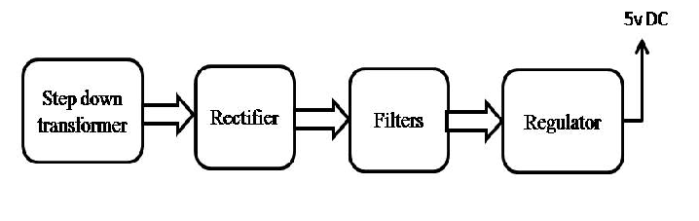
Block diagram:
