Employee login and logout details using RF with display on PC

The project aims in designing a system which is capable of displaying the login and logout details of employees on PC using wireless RF technology.

The modules present in the project are: keypad for entering the password assigned to the employee, RF transmitter and RF receiver to establish wireless communication, MAX 232 a line-driver to obtain RS 232 voltage levels, Real Time Clock which helps in acquiring employee login and logout time.

RF Communication ranges in between 30 KHz to 300 GHz. RF communication works by creating electromagnetic waves at a source and being able to pick up those electromagnetic waves at a particular destination. These electromagnetic waves travel through the air at near to speed of light. The wavelength of an electromagnetic signal is inversely proportional to the frequency, the higher the frequency, the shorter the wavelength.

MAX 232 is a chip which converts the voltage level from TTL levels to RS 232 levels or vice versa. When communicating with various micro processors one needs to convert the RS232 levels down to lower levels, typically 3.3 or 5.0 Volts.

The controlling device of the whole system is Microcontroller. This project makes use of two Microcontrollers; one at the entrance and other at PC. Keypad, RF transmitter is interfaced to the Microcontroller at entrance. Whenever an employee enters the password assigned to him, the controller processes the data and sends it through RF transmitter. This data will be received by RF receiver present at PC and feds this as input to the controller. The Microcontroller processes this data and displays it on PC. The Microcontroller is programmed using Embedded C language.

The main objectives of the project are:

- Login and logout details display on PC.
- Wireless transmission.

The project provides the following learning’s:

- RF communication.
- Interfacing PC to Microcontroller.
- Conversion of AC supply to DC supply.
- Embedded C programming.
- PCB design.

The main building blocks of the project are:

- Regulated Power Supply.
- Microcontroller.
- Keypad.
- RF transmitter.
- RF receiver.
- MAX232.
- Real Time Clock (RTC).
- Crystal oscillator.
- LED indicators.

Software used:

- PIC-C compiler for Embedded C programming.
- PIC kit 2 programmer for dumping code into Micro controller.
- Express SCH for Circuit design.
- Proteus for hardware simulation.
Regulated Power Supply:

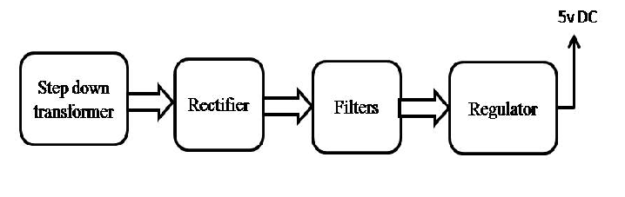
Block diagram:
