RFID based medical information system

The main aim of the project is to design a large storage capacity system which is capable of checking the expiry date of medicines and alerting if expiry occurred. Many people keep forgetting the information very often, and to remember them they need storage device. So, they store the data in their mobile phones, which can’t be maintained permanently and if the phone is lost the data is lost permanently. Hence to avoid this we design a storage device using 1GB MMC/SD Memory Card. This project mainly useful for medical department people to check the medicine expiries easily and this device also supports data storage by multiple persons at the same time.

MMC card is the acronym for Multimedia Memory Card, which is available in the market with different storage capacities. The storage capacity of these cards ranges between few MB (mega bytes- few Giga bytes). These cards are also termed as SD card, which stand for Secure Digital card. These MMC/SD card performs communication using a well-defined protocol known as SPI (serial peripheral interfacing). In write mode it writes the data into the MMC card, while in the read mode it reads the data from the memory card. It also makes use of one more control button to format the data in the memory card.

The main objective of this project is to store the data of all the medicine prescribed information like medicine name, expiry date, and manufacturing dates etc in the form of text in the MMC/SD memory card. The RFID tag is attached to each medicine in the medical department. The RFID reader decodes the RFID tag of the particular medicine and sends the data to the microcontroller. The controller is used to check the data of the particular medicine which is stored in MMC card interfacing to it. The data of the medicine is displayed on LCD. When the medicine expiry date is beyond the date prescribed in the MMC card it alerts with the buzzer sound and also displays on LCD.

The main objective of this project is:

- Storing the medicine data using 1 GB MMC card.
- Monitoring medicine using RFID technology.
- The data of the medicine is displayed on LCD.

The project provides learning’s on the following advancements:

- RFID technology.
- RFID reader and micro controller interface.
- 1 GB MMC card for storing data
- Interface of LCD and Buzzer to micro controller.
- Embedded C programming.
- PCB design.

The major building blocks of this project are:

- Regulated power supply.
- Micro controller.
- RFID reader and tags.
- LED Indicators.
- LCD driver and LCD.
- Crystal Oscillator.
- MMC/SD memory card with driver.
- Buzzer with driver.

Software used:

- PIC-C compiler for Embedded C programming.
- PIC kit 2 programmer for dumping code into Micro controller.
- Express SCH for Circuit design.
- Proteus for hardware simulation.

Regulated Power Supply:

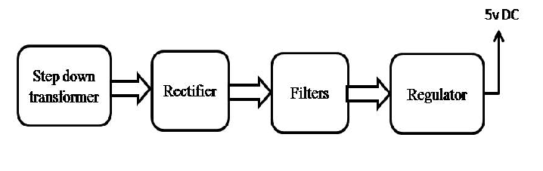
Block diagram:

