RFID based shopping trolley

This project aims in designing a user friendly, automatic shopping trolley and data storing system of the number goods on trolley in big shopping malls using RFID technology and display on the LCD (Liquid Crystal Display).

Automation is the most frequently spelled term in the field of electronics. The hunger for automation brought many revolutions in the existing technologies. One among the technologies which had greater developments is RF communications. The result of this is the RFID cards which transmit a unique identification number. This number transmitted by the RFID can be read with the help of a RF reader.

The RFID reader is interfaced with the microcontroller and RFID tag is attached to each and every good package. When the goods are moving on the trolley with conveyer belt using geared DC motor the RFID tags attached to the goods are decoded by the RFID reader interfaced to the microcontroller and the information is stored and displayed on LCD.

The project consists of RFID module, geared DC motors, LCD display and microcontroller. The input module is the RFID reader which gives the information of the good when it decodes the RFID tag of the good, this information is displayed on the LCD. The output modules are geared DC motor and LCD. The geared DC motor is used for the movement of conveyer belt setup. When the RFID tag of the good is decoded by the RFID reader, then the conveyer belt is operated using geared DC motor for the next good to approach near the system and continuously monitors. The entire data related to goods are stored in the microcontroller and also displays on LCD.

In this project, a RFID module is used for decoding the RFID tag of the good, geared DC motor for the conveyer belt setup and LCD display is used for displaying the information of the good. This application is very useful in big shopping malls to store data of all the goods in the departmental stores, and to display on LCD using RFID technology.

This project makes use of an onboard computer, which is commonly termed as micro controller. It acts as heart of the project. This onboard computer can efficiently communicate with the output and input modules which are being used. The controller is provided with some internal memory to hold the code. This memory is used to dump some set of assembly instructions into the controller. And the functioning of the controller is dependent on these assembly instructions.

Features of this project:

- User-friendly interfacing.
- Information related to the goods display on LCD.
- RFID based Wireless Communication.
- Geared DC motor for conveyer belt setup.

This project provides exposure to the following technologies:

- Behavior of RFID module.
- Interfacing RFID module with the microcontroller.
- RFID reader and Tags.
- Interfacing geared DC motor and driver with microcontroller.
- Embedded C programming.
- PCB designing.

The main building blocks of the project are:

  - Regulated Power Supply.
  - Microcontroller.
  - RFID reader.
  - RFID tag.
  - Reset.
  - Crystal oscillator.
  - Geared DC motor with driver.
  - LCD display with driver.
  - LED indicators.

Software used:

- PIC-C compiler for Embedded C programming.
- PIC kit 2 programmer for dumping code into Micro controller.
- Express SCH for Circuit design.
- Proteus for hardware simulation.

Regulated Power Supply:

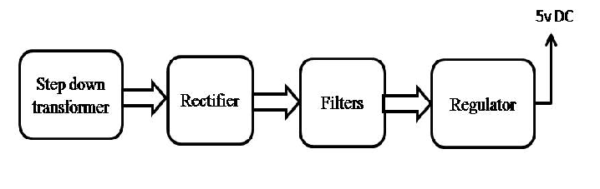

Block Diagram:

