RFID based bus identification system for blind with voice

The project mainly aims in designing a bus identification system for blind using RFID and voice module. This system is very much helpful for the blind/illiterate in identifying the exact bus related to his/her destination area.

Automation is the most frequently spelled term in the field of electronics. The hunger for automation brought many revolutions in the existing technologies. One among the technologies which had greater developments is RF communications. The result of this is the RFID cards which transmit a unique identification number. This number transmitted by the RFID can be read with the help of a RF reader.

The project consists of a RFID module, LCD, voice module, and a microcontroller mother board. The RFID tags are attached to the busses and the entire system is at the bus stop. Whenever the bus reaches the bus stop the RFID tag attached to the bus is decoded by the RFID reader at the bus stop and announces the bus information using voice module and also displays on the LCD.

Micro controller is the heart of the device. It stores the data of the buses and the RFID reader which is interfaced to the microcontroller decodes the RFID tag attached to the bus. Whenever the bus reaches the bus station the system gives an alerting voice message of the bus information and also displays on LCD. This device is designed to provide with a greater advantage producing voice based announcement for the user especially for the blind /illiterate person to recognize the bus required to reach the destination area.

The main features of this project are:

- User-friendly interaction.
- Highly sensitive.
- Reliable for blind/illiterate people.
- Easy to operate.

This project provides learning’s on the following advancements:

- Characteristics of voice module.
- Voice generation circuit.
- RFID module.
- Conversion of AC supply to DC supply.
- Embedded C programming.
- PCB design.

The major building blocks of this project are:
- Regulated Power Supply
- RFID reader and RFID tag.
- Voice Circuit
- LCD with driver.
- Micro controller.
- Crystal oscillator.
- LED indicators.

Software used:

- PIC-C compiler for Embedded C programming.
- PIC kit 2 programmer for dumping code into Micro controller.
- Express SCH for Circuit design.
- Proteus for hardware simulation.

Regulated Power Supply:
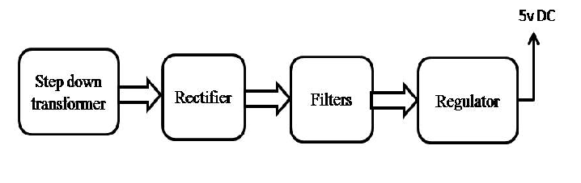

Block diagram:

