Human body temperature and heart rate monitoring and alerting through SMS
The project aims in designing a system which is capable of tracking the location of cardiac patients and also monitoring of heart rate alerts in case of emergency through SMS to predefined numbers. Now a day’s technology is running with time, it completely occupied the life style of human beings. It is being used everywhere in our daily life to fulfil our requirements. We can not only increase the comfort of life but also increase the health monitoring techniques by making use of advanced technology. In this project we are making use of technology to sense serious health problems so that efficient medical services can be provided to the patient in appropriate time.

This project aims in sending alert messages in emergency times, i.e. when a person is alone in home or travelling and his heartbeat or body temperature rises or lowers then alerting messages will be send to the mobile phone. Also, we can get the heart rate of the person by simply sending a pre-defined format SMS. Here we get the alerting message from the GSM modem (SMS Message).

The functioning of this device is based on the truth that the blood level circulation during expansion and contraction of heart which can be sensed by Heartbeat sensor. Depending upon the rate of circulation of blood per second the heart beat rate per minute is calculated. This device consists of a microcontroller which takes the input from the heart beat sensor and calculates the heart rate of the patient. The micro controller takes the responsibility to send alert messages through GSM modem whenever it is necessary. The Microcontroller is programmed using Embedded C language.

The main objectives of the project are:
- Real time monitoring of health status of a person.
- Alerts in emergency to predefined numbers.
- Works anywhere in the world (with GSM availability).

The project provides learning’s on the following advancements:
- Heartbeat sensor.
- Temperature sensor.
- LED and LDR characteristics.
- GSM modem and micro controller interface.
- Visual and audible alerts through LCD and buzzer
- Conversion of AC supply to DC supply.
- Embedded C programming.
- PCB design.

The major building blocks of this project are:
- Regulated power supply.
- Micro controller.
- Heart beat sensor.
- GSM modem.
- LCD.
- Reset.
- LED Indicators.
- Buzzer with driver.
- Crystal Oscillator

Software used:

- PIC-C compiler for Embedded C programming.
- PIC kit 2 programmer for dumping code into Micro controller.
- Express SCH for Circuit design.
- Proteus for hardware simulation.

Regulated Power Supply:

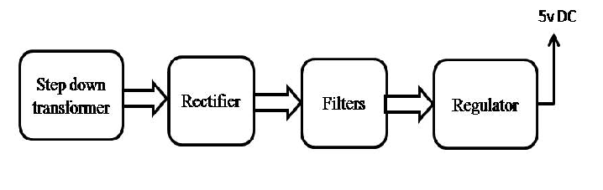
Block diagram:

