PIR based intrusion detection system with letter box information without using Microcontroller

The project aims in designing a system which is capable of identifying the human presence in restricted areas and automatically alerts through buzzer. The proposed system has been designed to improve the security feature of a house or a industry. Also, the system is capable alerting regarding the ne w mail arrived with the help of IR sensor.

The system makes use of a comparator. The output from PIR and IR sensor is fed to comparator. The comparator will continuously compare output from PIR and IR and reference voltage and generates logic low or high. The output generated from comparator is used to drive a Buzzer.

The major features of this project are:

- Motion sensing using PIR sensor.
- Alerting regarding thieves through buzzer.
- Alerting regarding mails.

The project provides learning’s on the following advancements:

- Characteristics of PIR sensor.
- Characteristics of IR sensor.
- Conversion of AC supply to DC supply.
- Comparator working principle.
- Need for drivers.
- PCB design.

The major building blocks of this project are:

- Regulated Power Supply.
- Comparator.
- PIR sensor.
- IR sensor.
- Buzzer with driver.
- Reference voltage (Potentiometer).

Regulated Power Supply:

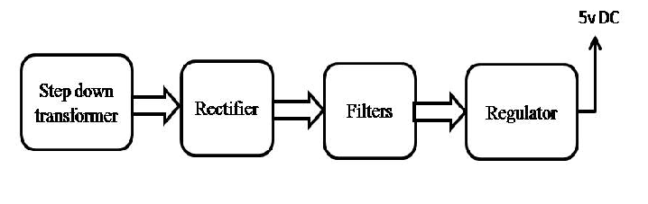

Block Diagram:

