High Sensitive LDR based Automatic night lamp with morning alarm

The aim of the project is to construct intelligent day/ night detector. Also, the system is capable of turning ON the night lamp automatically during night. The system gives a morning alarm. The system is capable of holding the alert for predefined time set using taper POT available in the system.

The 555 Timer IC is an integrated circuit (chip) that can act as a timer or an oscillator. The IC was designed by Hans R. Camenzind in 1970 and brought to market in 1971 by Signetics. The 555 timer integrated circuit (IC) has become a mainstay in electronics design. A 555 timer will produce a pulse when a trigger signal is applied to it. The pulse length is determined by charging then discharging a capacitor connected to a 555 timer. A 555 timer can be used to deboune switches, modulate signals, create accurate clock signals, create pulse width modulated (PWM) signals, etc.

The features of the project are:

- Alerts regarding mails through buzzer.
- Alerting time can be adjusted.

The project provides the following learning’s:

- 555 timer operating modes.
- LDR (Light Dependent Resistor characteristics).
- Relay working principle.
- Comparator working principle.
- Circuit designing techniques.

The major building blocks of this system are:

- Regulated Power Supply.
- 555timer.
- Taper POT.
- Buzzer with driver.
- LDR (Light Dependent Resistor).
- Reference voltage (POT).
- Relay.
- Night lamp.

Regulated Power Supply:

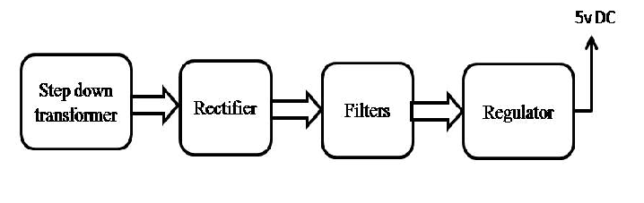

Block Diagram:

