Hazardous chemical valve control system with stepper motor and RC5 remote control

The project aims at designing a safer way of operating a chemical valve. Here in the project the valve is either opened/closed using an IR remote control. The chemical valve is fixed to a stepper motor which helps in opening/ closing possible through controller based system.

The controlling device of the system is a Microcontroller. Stepper motor, IR receiver are interfaced to Microcontroller. A predefined button press in a IR remote control will send the data, which will receive by the IR receiver interfaced to Microcontroller. The Microcontroller validates the button and acts accordingly on the stepper motor which is capable of performing opening/closing operation. In achieving the task the controller is loaded with a program written using Embedded ‘C’ language.

The main objectives of the project are:

- Wireless opening of a chemical valve.
- Usage of IR technology.

The project provides exposure to following technologies:

- IR Technology.
- Interfacing IR receiver to Microcontroller.
- Stepper motor working principle.
- Interfacing of stepper motor to Microcontroller.
- Embedded ‘C’ language.
- PCB designing.

The major building blocks of the project are:

- Regulated Power Supply.
- Microcontroller.
- IR receiver.
- IR remote control.
- Stepper motor with driver.
- Crystal oscillator.
- Reset.
- LED indicators.

Software used:

- PIC-C compiler for Embedded C programming.
- PIC kit 2 programmer for dumping code into Micro controller.
- Express SCH for Circuit design.
- Proteus for hardware simulation.

Regulated Power Supply:

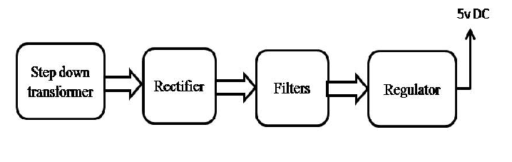

Block diagram:
