HIGHLY SENSITIVE ELECTRONIC EAR

The purpose of this project is to construct a real time highly sensitive electronic ear system. In this Project one piezo electric micro phone with interfacing unit is designed using a microcontroller and when any person knocks the door gives an alarm using high intensive buzzer alarm system.

The microcontroller is the heart of the unit & controls all the input and output modules. One piezo electric micro phone is interfaced with microcontroller through a transistor switch. When any person knocks the door the micro phone gives a signal to the microcontroller. The controller reads the input from the piezo electric phone and alerts through buzzer alarm system through driver.

The firmware is developed in Embedded ‘C’ language and compiled using PIC ‘C’ compiler. The final output of compiler will be in the form of Hex file. That Hex file is programmed/copied in to PIC microcontroller Flash program memory.

Features:
- Accurate alerting is obtained.
- Easy to implement.
- Fast response
- User friendly and easily operable
- More efficient and low cost design

Regulated power supply:
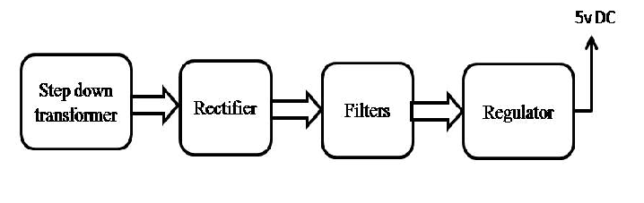
Block diagram:

