Construction of Cooking gas leakage sensor and alarming system without using Microcontroller

The project aims in designing a system which is capable of sensing gas leakages and alerts regarding the leakages using buzzer. Also, the system has a provision for changing the intensity of gas leakages.

The system makes use of a comparator. The output from gas sensor is fed to
comparator. The comparator will continuously compare output from gas sensor and reference voltage and generates logic low or high. The output generated from comparator is used to drive a Buzzer.

The major features of this project are:

- Automated gas sensing alerting system.
- Intensity of gas leakage can be adjusted.

The project provides learning’s on the following advancements:

- Characteristics of gas sensor.
- Conversion of AC supply to DC supply.
- Comparator working principle.
- Need for drivers.
- PCB design.

The major building blocks of this project are:

- Regulated Power Supply.
- Comparator.
- Gas sensor.
- Buzzer with driver.
- Reference voltage (Potentiometer).

Regulated Power Supply:

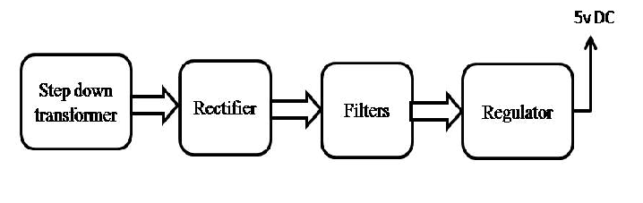
Block Diagram:

