Portable Camera Based Assistive Text and Product Label Reading From Hand Held Objects for Blind Persons

ABSTRACT

We propose a camera-based assistive text reading framework to help blind persons read text labels and product packaging from hand-held objects in their daily lives. To isolate the object from cluttered backgrounds or other surrounding objects in the camera view, we first propose an efficient and effective motion based method to define a region of interest (ROI) in the video by asking the user to show the object or text. This method extracts object or text region by a mixture-of-Gaussians-based background subtraction method. In the extracted ROI, text localization and recognition are conducted to acquire text information. To automatically localize the text regions from the object ROI, we propose a novel text localization algorithm by learning gradient features of stroke orientations and distributions of edge pixels in a text reading algorithm. Text characters in the localized text regions are then binarized and recognized by off-the-shelf optical character recognition software. We explore user interface issues and assess robustness of the algorithm in extracting and reading text from different objects with complex backgrounds

Existing System:
In the existing system, they shown to analyze the text shown to the system but which is only not sufficient for the blind people, and the technique implemented has drawback of slow processing.
Proposed System:
In the proposed system, we will implement a novel algorithm to read the text shown to the USB camera as well develop a voice output for the analyzed text such that the blind persons can hear the name of the product.
BLOCK DIAGRAM

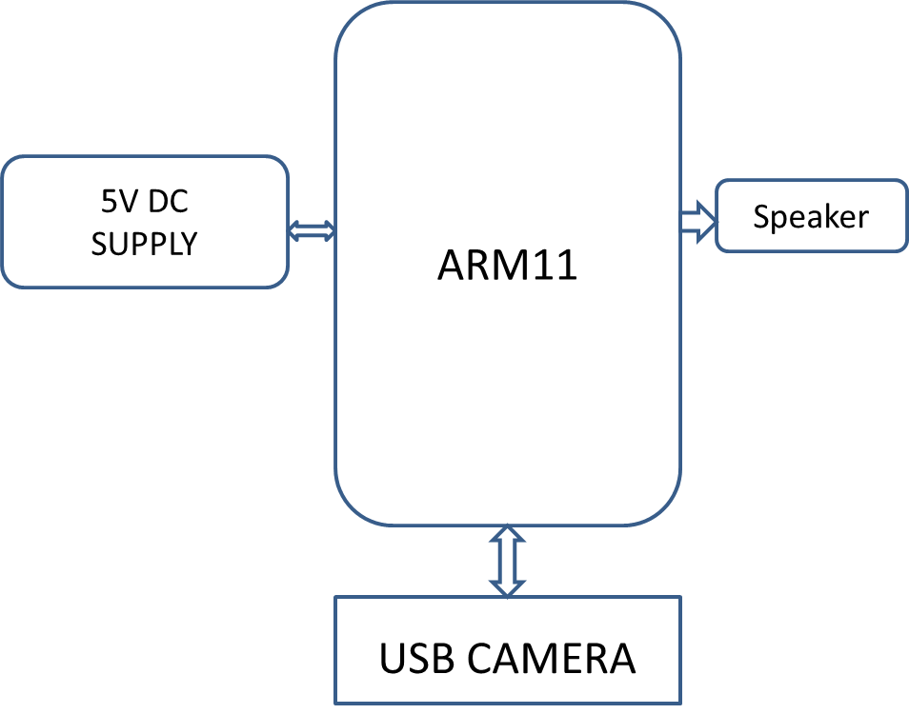
Software:
Linux OS, C/C++, Open CV.
Hardware:
ARM11 (Raspberry Pi), USB Camera, Speaker.
Applications:
Shopping Malls, Medical Stores
Advantages:
- No need of Human guidance
- Less Susceptible to error.

