Localization of License Plate Number Using Dynamic Image Processing Techniques And Genetic Algorithms

ABSTRACT

In this research, a design of a new genetic algorithm (GA) is introduced to detect the locations of the License Plate (LP) symbols. An adaptive threshold method has been applied to overcome the dynamic changes of illumination conditions when converting the image into binary. Open ALPR (Automated License Plate Recognition) is used to detect candidate objects inside the image. This method relies on identifying the key characteristic of a number plate the concentration of characters with strong light-on-dark edges. The system which reads number plates from any digital image, color or monochrome, sizes range from 640×480 to megapixel images. There are three major steps to number plate reading. Locating and isolating the number plates in the image, Locating and isolating the characters in the number plate, Reading the characters (OCR, optical character recognition).

Existing System:

The existing system concept algorithm is very complicated to be implemented on a real time hardware platform; as well in their approach they have not proved the practical implementation part.

Proposed System:
In the Proposed algorithm to be developed will locate strong edges which are spaced proportionally given the expected size of the plate relative to the overall image. A strong edge is defined as a vertical line where adjacent pixels have high luminance deltas, relative to other areas of the scene. Using which the accuracy of license plate detection will be high.

BLOCK DIAGRAM
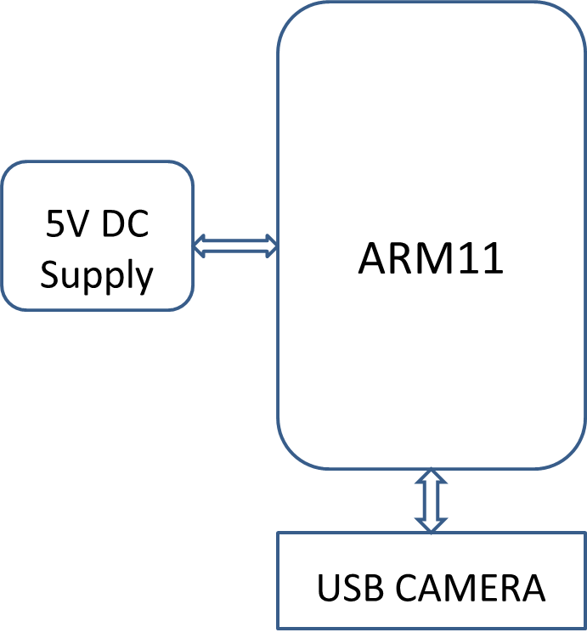
Software: Linux OS, C/C++, Open CV.
Hardware: ARM11(Raspberry Pi), USB Camera.
Applications: Theft vehicle identification, Toll gates
Advantages: Low manpower requirement, High accuracy

