IoT enabled Biometric Voting Machine

The Biometric Voting Machine project presents an innovative and secure voting system, leveraging an Arduino Uno microcontroller, Fingerprint module, LCD display, WiFi connectivity via ESP8266, and push buttons for user interactions. The system offers features such as fingerprint enrollment, modification, and deletion, as well as a streamlined voting process with candidate selection and prevention of multiple votes. Results are displayed on both the 16x2 LCD and a web browser over WiFi. The inclusion of EEPROM memory ensures persistent storage of casted votes, and the system operates on 5V DC for portability. The abstract encapsulates the project's commitment to user-friendly biometric authentication, transparent voting procedures, and technological integration for a reliable and efficient electoral process.

Major Components Used:
- Arduino Uno Microcontroller Board
- R307 Fingerprint Module
- 16x2 LCD Display
- Buzzer
- ESP8266 WiFi Module
- Push Buttons (Enroll, Modify, Delete, Start Voting, Results)
- Power Bank/USB Power Supply

System Features:
- Fingerprint Enrollment: Users can enroll their fingerprints using the dedicated push buttons.
- Fingerprint Modification and Deletion: Admin users have the ability to modify or delete registered fingerprints.
- Voting Process: The system allows registered voters to cast their votes using a dedicated button.
- LCD Display: All system processes, including enrollment, modification, deletion, and voting, are displayed on the 16x2 LCD.
- WiFi Connectivity: Results are displayed on both the LCD and a connected web browser over WiFi using the ESP8266 module.
- Candidate Selection: Voters can choose from three candidates using push buttons.
- Vote Validation: The system checks if a user has already cast a vote to prevent multiple votes.
- EEPROM Memory: Casted votes are stored in the EEPROM memory to ensure data persistence.
- Vote Clearing: Admin users can clear casted votes to prepare for the next voting cycle.
- Power Supply: The system operates on 5V DC, making it portable and powered by a power bank or USB power supply.
Block Diagram:
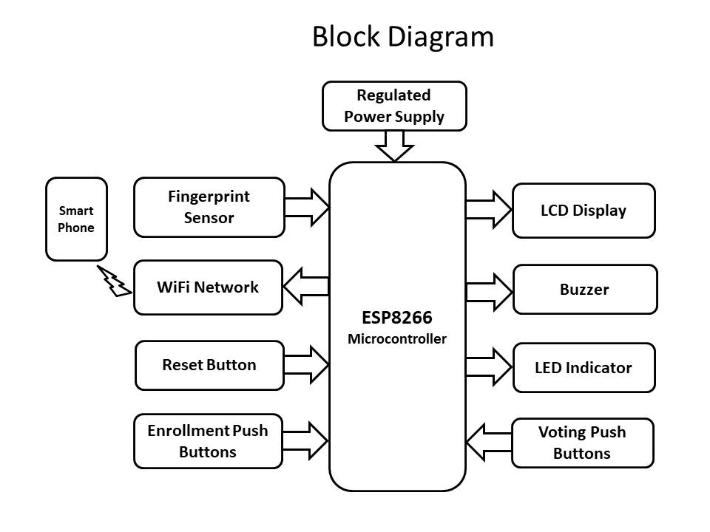
Workflow:
- Users enroll fingerprints using the "Enroll" button.
- Admin users can modify or delete fingerprints as needed.
- Registered voters press the "Start Voting" button to initiate the voting process.
- Users select a candidate using dedicated push buttons, and the system prevents multiple votes.
- Admin users can clear casted votes using a specific button for next voting.
- To view results, the admin user places their fingerprint and presses the "Results" button.

Conclusion:
The Biometric Voting Machine provides a secure, user-friendly, and efficient voting system. The integration of biometric authentication, LCD display, and WiFi connectivity enhances the overall functionality, ensuring a reliable and tamper-resistant voting process.

Future Improvements:
- Implement additional security measures.
- Enhance user interface and experience.
- Explore the possibility of using more advanced fingerprint recognition technology.
- Consider integration with a centralized database for scalability.

Advantages:

1. Enhanced Security: Biometric authentication ensures a high level of security by uniquely identifying voters through their fingerprints, reducing the risk of identity fraud.
2. User-Friendly Interface: The inclusion of a 16x2 LCD display and push buttons provides a simple and intuitive interface for users to enroll, modify, and delete fingerprints, as well as cast their votes.
3. Prevention of Multiple Votes: The system's capability to check and prevent users from casting multiple votes ensures the integrity of the voting process, promoting fairness and accuracy in election results.
4. Real-time Results: The integration of an ESP8266 WiFi module allows for real-time transmission of voting results to a web browser, enhancing transparency and providing instant access to outcome data.
5. Portability and Accessibility: Operating on 5V DC power, the system is easily portable and can be powered by a power bank or USB supply, making it accessible for use in various locations.
6. Data Persistence: The use of EEPROM memory ensures the persistent storage of casted votes, even in the event of a power outage, providing data reliability and continuity.
7. Administrator Control: Admin users have the ability to manage fingerprints, clear casted votes, and oversee the entire voting process, adding a layer of control and accountability.
8. Scalability: The system can be expanded and scaled to accommodate a larger number of voters and candidates by potentially integrating with a centralized database.
9. Audible Feedback: The inclusion of a buzzer provides audible feedback during various stages of the voting process, enhancing user engagement and system responsiveness.
10. Cost-Effective Solution: Utilizing readily available and affordable components such as Arduino Uno and ESP8266 makes the system a cost-effective solution for implementing a biometric voting system, especially in resource-constrained environments.

Applications:

1. National Elections: Implementing the biometric voting system in national elections can enhance the security and transparency of the voting process, reducing the risk of voter fraud and ensuring the accuracy of election results.
2. Local Government Elections: Municipalities and local government bodies can adopt this technology to conduct fair and secure elections, providing a streamlined process for residents to cast their votes.
3. Corporate Elections: Organizations and companies can use the biometric voting system for internal elections, such as selecting representatives for employee councils or making decisions on important matters through a secure and reliable voting process.
4. Educational Institutions: Student government elections, faculty decisions, and other institutional voting processes within schools, colleges, and universities can benefit from the enhanced security and efficiency offered by the biometric system.
5. Community Organizations: Community groups, clubs, and associations can use this technology for conducting elections, facilitating decision-making processes, and ensuring a fair representation of members' preferences.
6. Nonprofit Organizations: NGOs and nonprofit organizations can employ the biometric voting system for board elections, project decision-making, and other governance-related activities to enhance transparency and credibility.
7. Specialized Voting Events: The system can be adapted for specific voting events, such as referendums, where a secure and verifiable voting process is essential to ensure the legitimacy of the results.
8. Remote or Mobile Voting Stations: The portability of the system, coupled with its ability to operate on 5V DC power, makes it suitable for use in remote or mobile voting stations, reaching voters in areas where traditional infrastructure may be limited.
9. Secure Surveys and Polls: Beyond elections, the biometric voting system can be repurposed for secure surveys and polls, ensuring the authenticity of participant responses and maintaining the integrity of data collection.
10. Accessible Voting for Differently Abled Individuals: The user-friendly interface of the system, coupled with biometric authentication, can contribute to making the voting process more accessible and inclusive for differently abled individuals.
By adapting the Biometric Voting Machine to these various applications, the project can significantly contribute to the improvement of democratic processes, decision-making, and governance across different sectors.

