IOT BASED DATA LOGGER WITH DEVICE CONTROL

IOT based data logger is an excellent way to monitor and control the environmental condition as well as equipment working status in industry, home etc., from anywhere in the world. IOTDL (IOT based data logger) collects the information by all kind of sensors. We are making use few sensors (Temperature and Light level) who’s values are logged on web browser over IoT (WiFi) communication. User can also control the relays connected to microcontroller over web browser as per users requirement.
For IoT communication, we are making use of 32bit esp8266 controller along with PIC microcontroller for sensors interface. This project makes use of an onboard computer, which is commonly termed as micro controller. It acts as heart of the project. This onboard computer can efficiently communicate with the output and input modules which are being used. The controller is provided with some internal memory to hold the code. This memory is used to dump some set of assembly instructions into the controller. And the functioning of the controller is dependent on these assembly instructions.
Micro controller gets the data from different sensors used and sends the same to the webpage created using IoT webserver technology. So that anyone can check the sensors parameters of that area from any were within Wi-Fi range.

The project provides us exposure on:
- Interfacing of microcontroller.
- Embedded C programming
- PCB designing.
- IoT technology
- Serial Communicationinterfacing.
- WIFI technology.
- Sensors interfacing.
- Power supply design.

The major building blocks of this project are:
- Regulated Power Supply.
- Microcontroller.
- Esp8266 WiFi Module.
- LM35 Temperature sensor
- LDR sensor
- Relay Boards
- LED Indicators.
- Reset button
- Crystal Oscillator.
Software’s used:

  - PIC-C compiler for Embedded C programming.
  - PIC kit 2 programmer for dumping code into Micro controller.
  - Express SCH for Circuit design.

REGULATED POWER SUPPLY:
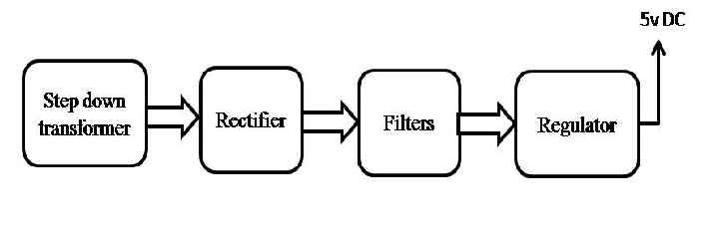

BLOCK DIAGRAM:
