GSM and RFID based High way Toll Collection

The aim of this project is to provide an efficient solution for automatic toll gate control and toll collection for high ways using RFID. This system also enables the remote monitoring and control of toll gate based on RFID technology. The information is also sent to the user through GSM-SMS Services.

Automation is the most frequently spelled term in the field of electronics. The hunger for automation brought many revolutions in the existing technologies. One among the technologies which had greater developments is RF communications. The result of this is the RFID cards which transmit a unique identification number. This number transmitted by the RFID can be read with the help of a RF reader.

The project makes use of a microcontroller, which acts as a central controlling unit. This module is capable of communicating with the input and the output modules. The user initially has to deposit money in the card number. The input module is the RFID reader which decodes the RFID tag which is with the vehicle and reduces the money directly from the RFID tag (card number). The output module is formed by the servo motor used for closing and opening of toll gates and also displays the status of the gate on LCD. The Microcontroller is programmed using Embedded C language.

The major ambition of this system is to remotely operate the gateways and automatically receive the feed back in overflow situations.

The main objectives of the project are:

- Automatic toll collection.
- Automatic gate opening/closing.
- Message alert of toll payment will be sent through GSM

The advantages of this project are:

- Automatic controlling of the toll gates for high ways.
- Automatic toll collection based on RFID.
- Monitoring can be displayed on LCD.
- 24x7 Monitoring and control of toll gate.

This project provides us with the learning’s on the following aspects:

- Interfacing Stepper Motor with Microcontroller.
- RFID based toll collection.
- Reading the input from the RFID reader.
- Interfacing RFID reader with microcontroller.
- Interfacing GSM with Microcontroller
- Embedded C programming.
- PCB designing.

The major building blocks of this project are:

- Regulated power supply.
- Microcontroller.
- RFID reader.
- RFID tag.
- GSM Modem.
- Crystal oscillator.
- Servo motor.
- LED Indicators.
- LCD display with driver.
- Buzzer.

Software used:

- PIC-C compiler for Embedded C programming.
- PIC kit 2 programmer for dumping code into Micro controller.
- Express SCH for Circuit design.
- Proteus for hardware simulation.

Regulated Power Supply:
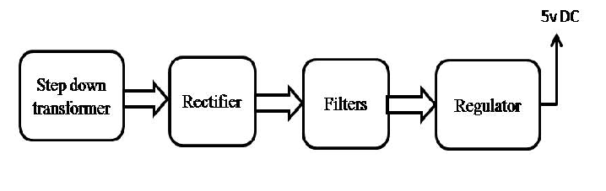
Block diagram:
