GSM and GPRS (Web) based Energy meter with tampering alert

The project aims at developing a system which helps in monitoring the readings from an energy meter and controlling the switching of energy meter. This system also has tamper switch, which helps in illegal removing of energy meter cabinet and alerts the authorities in the form of text message. This also sends data to webpage in realtime with tamper alert status too.

The controlling device is a Microcontroller. GSM/GPRS modem, Relay, LCD, tamper switch and energy meter are interfaced to Microcontroller. The microcontroller is programmed such that it sends the energy readings to the authorities by sending simple SMS to the system. It helps controlling the energy meter along with tampering proof facility. The readings are displayed on LCD. The Microcontroller is loaded with intelligent program written using Embedded ‘C’ language.

The modules in the project are: GSM/GPRS modem for establishing communication between system at house and electricity department, Energy meter which continuously gives usage details, LCD to display current reading of meter, Relay to disconnect the power in case of nonpayment of bill.

Features:

- Provides user friendly remote energy meter monitoring.
- Supports controlling of meter.
- Can be controlled anywhere in the world.
- Non-volatile memory based energy-reading storing.
- Auto disconnect feature.

Advantages:

- The system alerts through SMS and GPRS data onto a webpage.
- Tamper proof facility.
- Efficient and low cost design.
- Low power consumption.
- Fast and accurate result.

The project provides the following learning’s:

- Energy meter interfacing to Microcontroller.
- Relay working principle.
- GSM/GPRS modem interfacing to Microcontroller.
- Embedded C programming.
- PCB designing.

The major building blocks of this project are:
- Regulated Power Supply.
- Microcontroller.
- GSM Modem.
- Relay with driver.
- Digital Energy Meter.
- Optocoupler.
- LCD display with driver.
- Tamper proof switch.
- Crystal oscillator.
- Reset.
- LED indicators.

Software’s used:

- PIC-C compiler for Embedded C programming.
- PIC kit 2 programmer for dumping code into Micro controller.
- Express SCH for Circuit design.
Regulated Power Supply:

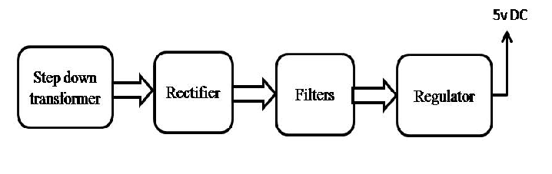
Block Diagram:

