Event driven automation with Android backup control

The project aims at designing an event driven automation system with android based backup control. The proposed automation technique is very innovative and well advanced one. The user has a provision of entering events like time, device status etc..,. The system alerts the user through a beep sound for every event being driven and the status of devices can be seen on LCD display. The user can select the devices and also events using keypad.

Android is a software stack for mobile devices that includes an operating system, middleware and key applications. Android boasts a healthy array of connectivity options, including Wi-Fi, Bluetooth, and wireless data over a cellular connection (for example, GPRS, EDGE (Enhanced Data rates for GSM Evolution) and 3G). Android provides access to a wide range of useful libraries and tools that can be used to build rich applications. In addition, Android includes a full set of tools that have been built from the ground up alongside the platform providing developers with high productivity and deep insight into their applications.

Bluetooth is an open standard specification for a radio frequency (RF)-based, short-range connectivity technology that promises to change the face of computing and wireless communication. It is designed to be an inexpensive, wireless networking system for all classes of portable devices, such as laptops, PDAs (personal digital assistants), and mobile phones. It also will enable wireless connections for desktop computers, making connections between monitors, printers, keyboards, and the CPU cable-free.

The controlling device of the whole system is a Microcontroller. Bluetooth module, 4-Relays board, Event selector using keypad, RTC (Real Time Clock), Buzzer and LCD display are interfaced to the Microcontroller. The data received by the Bluetooth module from Android smart phone is fed as input to the controller. The controller acts accordingly on the Relays to switch connected electrical appliances. Also, the Microcontroller continuously monitors the user given events and acts accordingly on the devices. Also, the status of the electrical appliances can be seen on LCD display. Every event being driven is indicated through a buzzer and the selection of events can be given using keypad. In achieving the task the controller is loaded with a program written using Embedded ‘C’ language.

The main objectives of the project are:

- Controlling of AC devices wirelessly through mobile phone.
- Usage of Android touchscreen smart phone in performing the task.
- Keypad based event driving technique.
- Bluetooth wireless transmission.
- Display of electrical appliances status on LCD.
- Buzzer based alarm system while event driving.

The project provides exposure to following technologies:

- Google’s Android Open Source Technology.
- Bluetooth wireless technology.
- Interfacing Bluetooth module to Microcontroller.
- Real Time Clock
- I2C protocol implementation.
- Electromagnetic Relay switching principles.
- Interfacing of 4-Relay board to Microcontroller.
- Embedded C programming.
- PCB designing.

The major building blocks of the project are:

- Regulated Power Supply.
- Microcontroller.
- Android smart phone.
- Bluetooth module.
- 4-Relay board with driver.
- LCD display with driver.
- Real Time Clock (RTC).
- Buzzer with driver.
- Event selector using keypad.
- Crystal oscillator.
- Reset.
- LED indicators.

Software’s used:

- PIC-C compiler for Embedded C programming.
- PIC kit 2 programmer for dumping code into Micro controller.
- Express SCH for Circuit design.
- Proteus for hardware simulation.

Regulated Power Supply:

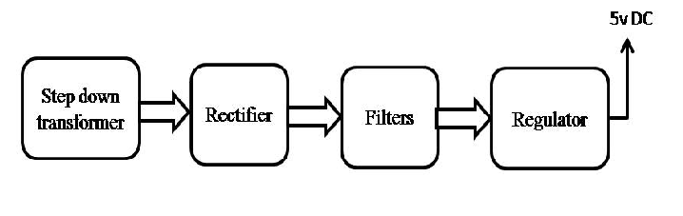

Block diagram:



