EEPROM based Pre-paid Energy meter

The project aims in designing a system which makes electric bill payment easier and also controlling of digital meter for electricity department becomes more easily using prepaid technology.

EEPROM based prepaid electricity is a unique and new concept which saves lot of time and power for electricity department. User can recharge the card whenever the power is required. Electricity department authorities send specially decoded data connected to the energy meter.

If the sufficient amount is recharged, then the electrical power department can send the message through EEPROM with unique identification number. So the power is delivered to user. Depending upon the user usage of power, money will be decreased depending up on the power consumption. And a LCD is placed to display the current readings.

Microcontroller is interfaced with internal EEPROM memory. “EEPROM based Pre-paid energy meter” is a modern era automation system where we can save the power. Here the devices to be controlled are interfaced with microcontroller unit, which is capable of performing the necessary tasks. The bill amount is also displayed on the LCD screen.

An EEPROM is provided on the board to store the updated recharge units and energy meter pulse count. At every instant the count value and units values are stored in EEPROM so that the data will not be lost even in power failure cases. When 1 unit is decremented from EEPROM the system will give a beep sound. When the recharged units become zero on power consumption, the system shutdown all the loads connected to it by giving a continuous beep sound. And the load will be disconnected from the supply with the help of relay. Again user has to recharge.

Features:

- Provides user friendly remote supply to energy meter.
- Supports controlling of meter.
- It can be controlled from electricity department.
- Non-volatile memory based energy-reading storing.
- Auto connect feature.

The project provides the following learning’s:

- Regulated power supplies.
- EEPROM.
- LCD display.
- Energy meter interfacing to Microcontroller.
- Buzzer.
- Relay with driver
- Embedded C programming.
- PCB designing.

The major building blocks of this project are:
- Regulated Power Supply.
- Microcontroller.
- EEPROM (Electrically Erasable Programmable Read Only Memory).
- Digital Energy Meter.
- Optocoupler.
- Relay with driver.
- LCD with driver.
- Crystal oscillator.
- LED indicators.

Applications:
- House electrical power automation systems.
- Railway electrical systems.
- Remote controlling systems.
- Automatic power billing systems.

Software’s used:

- PIC-C compiler for Embedded C programming.
- PIC kit 2 programmer for dumping code into Micro controller.
- Express SCH for Circuit design.
- Proteus for hardware simulation.

Regulated Power Supply:

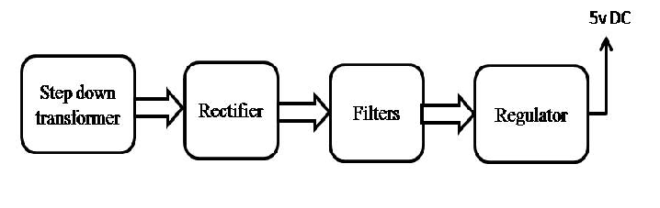

Block Diagram:

