Dead Reckoning Pedestrian Tracker
(Under Ground Tunnel Location Tracker without GPS Signal)

The "Dead Reckoning Pedestrian Tracker" is a cutting-edge project designed to overcome the limitations of GPS signal loss in environments such as tunnels. The system integrates a GPS receiver, a digital compass, and a footstep sensor with an ESP8266 (Wemos D1 Mini Board) Microcontroller to provide continuous location tracking even when GPS signals are unavailable.

Objectives:
1. Real-time GPS Tracking: The project leverages a GPS receiver to acquire live GPS coordinates when the signal is available, ensuring accurate positioning in open environments.
2. Dead Reckoning Algorithm: In GPS-denied regions, the system employs a dead reckoning algorithm. A digital compass determines the angle of movement, and a footstep sensor measures the distance traveled per step. This information, combined with the last valid GPS coordinates, enables the calculation of the current location.
3. User Interface: The system features an OLED display that shows live GPS coordinates when GPS is enabled. When GPS is disabled, the display provides calculated coordinates, compass angle, and step count. Additionally, a switch facilitates easy toggling between live GPS and dead reckoning modes.
4. Web Interface: The ESP8266 acts as a web server, allowing users to access tracking information via a web browser on their smartphones. By connecting to the system's Wi-Fi, users can view the same information displayed on the OLED, enhancing accessibility.

System Components:
- ESP8266 (Wemos D1 Mini Board)
- GPS Receiver
- Digital Compass
- Footstep Sensor
- OLED Display
- Switch for GPS Enable/Disable
- WiFi for Web Browser Display

System Block Diagram:
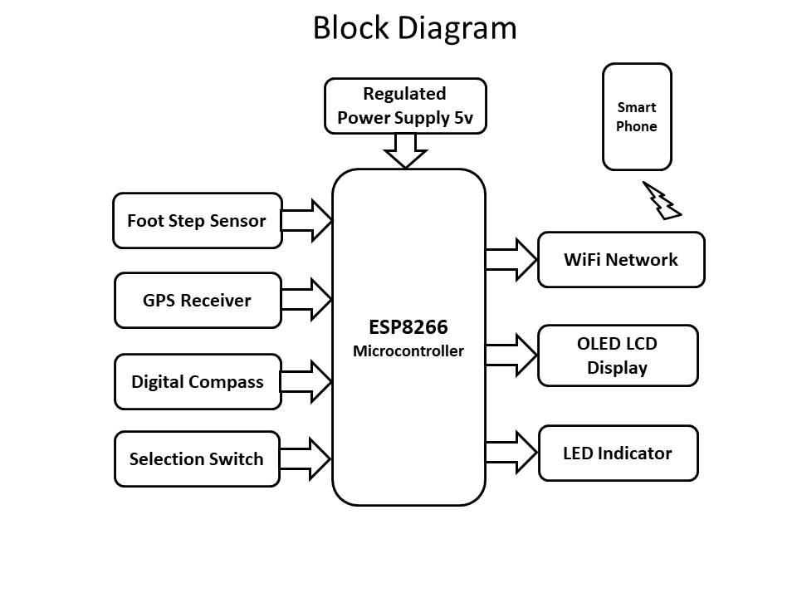
Project Demonstration:
The project's functionality can be easily demonstrated by enabling or disabling the GPS switch. Users can observe the transition between live GPS tracking and dead reckoning calculations, showcasing the system's adaptability in challenging navigation scenarios.
Web Interface
- ESP8266 acts as a web server.
- Users connect via a web browser using the SSID and password.
- Entering IP address (e.g., 192.168.4.1) in the web browser displays the same information as shown in OLED on the smartphone.

Applications:

1. Underground Navigation:
- Ideal for pedestrian navigation in tunnels, subway systems, or underground structures where GPS signals are often lost.

2. Urban Canyons:
- Navigating through urban environments with tall buildings that can obstruct GPS signals, providing continuous tracking.

3. Indoor Navigation:
- Useful for tracking movement within large indoor spaces, such as malls, airports, or exhibition halls, where GPS signals are weak or unavailable.

4. Military Operations:
- Military personnel navigating in areas with limited GPS availability, ensuring accurate tracking and coordination.

5. Surveying and Mapping:
- Useful for mapping and surveying tasks in areas with intermittent GPS signals, ensuring data accuracy.
Advantages:

1. Continuous Tracking:
- Provides uninterrupted location tracking by seamlessly transitioning between live GPS and dead reckoning modes.

2. Versatility:
- Adaptable to various environments, including those with GPS signal challenges, making it versatile for different applications.

3. Reduced Dependency on GPS:
- Offers a reliable solution in scenarios where GPS signals are weak, blocked, or unavailable, reducing dependence on satellite signals.

4. User-Friendly Interface:
- The inclusion of OLED display and web interface enhances user accessibility and provides real-time information in a user-friendly manner.

5. Cost-Effective:
- Compared to alternative solutions requiring additional infrastructure, the system is cost-effective as it leverages existing technologies.

6. Integration with Other Systems:
- Can be integrated with mapping APIs, emergency response systems, or other IoT devices, expanding its functionality and applications.

7. Low-Power Operation:
- With efficient power management, the system can operate for extended periods, making it suitable for long-duration tasks or scenarios without immediate access to power sources.

8. Demonstrable Technology:
- Demonstrates the feasibility of dead reckoning algorithms and sensor integration, serving as a proof-of-concept for similar applications in navigation and tracking.

Conclusion:

The "Dead Reckoning Pedestrian Tracker" represents a novel approach to address GPS signal loss challenges. By combining GPS, a digital compass, and a footstep sensor with the connectivity capabilities of the ESP8266, the system offers a comprehensive solution for continuous location tracking. The inclusion of both OLED and web interfaces ensures flexibility and user-friendly access to tracking information. This project holds promise for applications in GPS-denied environments, such as tunnels or urban canyons.

Future Enhancements

- Integration with mapping APIs for improved location visualization.
- Calibration features for optimizing dead reckoning accuracy.
- Enhanced power management for prolonged battery life.
- Compatibility with additional sensors for more robust tracking capabilities.

