DAM DOOR OPENING SYSTEM BASED ON WATER

INFLOW AT THE DAM

This project is an automated system where Dam gates are opened based on water inflow at the Dam.
In the proposed project we will be using a Water level sensor which will be detecting the rise of the level of water inside the Dam. With detection of water to a certain level the Dam door (which is a DC Servo Motor Operated) will open so that the excess water inside the dam flows out. If the water reaches to higher level the Dam door will open with a higher level so that the release of water is improvised. With this the flow of release of water from the dam is controlled. The electronic signal from the detector will be sent to the Microcontroller for processing. A DC Servo motor will be demonstrated as Dam Door opening system.
The heart of this project is the microcontroller used that continuously monitors the level of water using level sensor. Upon sensing alert levels it instruct the DC Servo motor to open the gate (servo position) at some predefined level. When the water level goes below alerting level then the gate level will goes down to normal state.

BLOCK DIAGRAM

Regulated Power Supply:
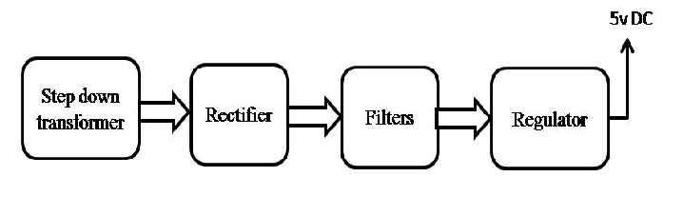
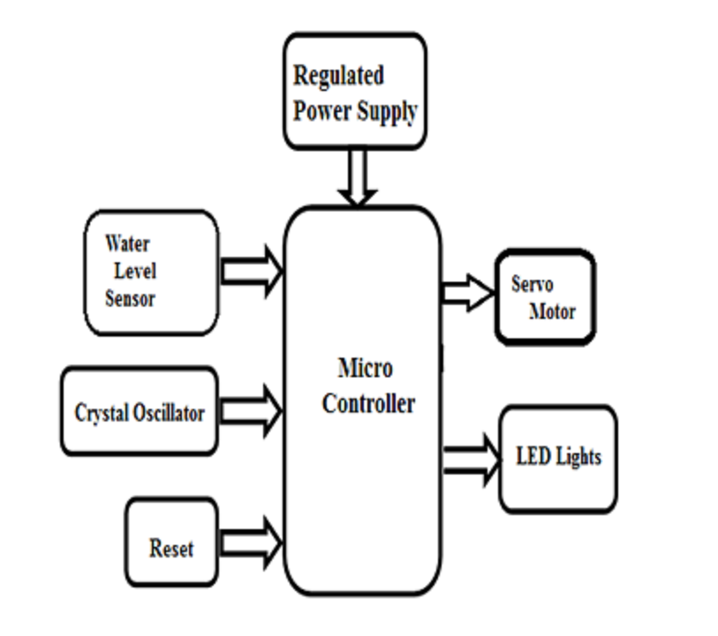

Major Building Blocks of this project

- Microcontroller
- Water Sensor
- DC Servo Motor
- LED Indicators
- Regulated Power Supply.

Software Used

- PIC-C compiler for Embedded C programming.
- PIC kit 2 programmer for dumping code into Micro controller.
- Express SCH for Circuit design.

