Automatic Traffic density control announcement system over FM

Automation has created a bigger hype in the electronics. The major reason for this hype is automation provides greater advantages like accuracy, energy conversation, reliability and more over the automated systems do not require any human attention. Any one of the requirements stated above demands for the design of an automated device. The energy conversation is very important in the current scenario and should be done to a maximum extent where ever it is possible. Energy can be effectively conserved if we can control the traffic lights on the highways by glowing them according with time delay. So in this situation we should think about a system which is capable of sensing the traffic density and automatically should manage to control the traffic levels by increasing the time delay for the green signal to the roads which are with heavy traffic.

The project aims at designing an intelligent traffic control system which is capable of estimating traffic density using IR vehicle density detection sensors and controls the traffic signals based on time delay. It also announces the status of traffic over FM radio using voice announcement system. The system makes use of IR sensors, High power LED‘s as traffic lights, Voice recording and playback system and microcontroller.

The controlling module of the whole system is a Microcontroller. The system uses traffic density IR sensor which are interfaced to Microcontroller. The traffic density sensor provides information regarding traffic as input to Microcontroller. The Microcontroller judges to increase the time delay in that direction and makes the green signal to glow for more delay time. To perform this intelligent task, Microcontroller is loaded with an intelligent program written using embedded ‘C’ language.

The major features of this project are:

- Automatic traffic lights control.
- Traffic density can be known by using IR sensors.
- Three levels to indicate Traffic density.
- Voice recording and playback system.

This project provides us learning’s on the following advancements:

- Interfacing of High power LEDs with microcontroller.
- Traffic density sensors interfacing. with microcontroller
- Embedded C programming.
- PCB design.

The major building blocks of this project are:

- Regulated Power Supply.
- Vehicle density IR sensor.
- High power LEDs
- Micro controller.
- Crystal oscillator.
- Voice recording and playback module.
- LED indicators.
- Reset Button

Software’s used:

- PIC-C compiler for Embedded C programming.
- PIC kit 2 programmer for dumping code into Micro controller.
- Express SCH for Circuit design.

Regulated Power Supply:

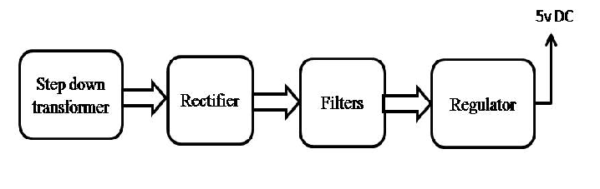

Block diagram:

