Automated Exhaust fan control system based on smoke and gas

The project aims at designing an intelligent smoke and gas detector. The system is capable of detecting smoke and gas levels in an industry and automatically controls the exhaust fan based on the intensity levels.

All industries must be familiar with the significance of a healthy environment provision to their workers. Industrial Ventilation is an important method for reducing employee exposures to airborne contaminants. Ventilation is used to reduce or remove contaminates from employees. Ventilation systems that range from simple wall-mounted propeller fans or roof-mounted mechanical ventilators to complex engineered designs. They are efficient air movers only as long as there is an adequate amount of make-up air supply. Makeup Air is air that enters the workroom to replace air exhausted through the ventilation system. A ventilation system will not work properly if there is not enough air in the room to exhaust.

So, the proposed system makes use of smoke and gas sensors which senses the intensity levels and fed this to a comparator. The comparator continuously monitors both gas and smoke and enables the relay switch if high intensity of smoke and gas is present. Relay switch is connected to a exhaust fan.

Regulated power supply:

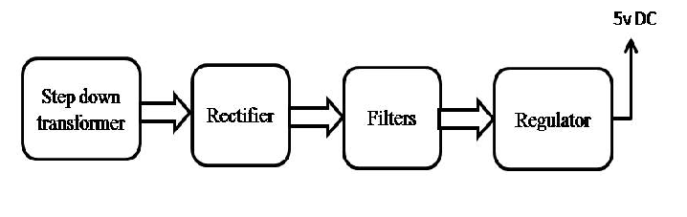

Block Diagram:
